Image processing 1 assignment task 1

Github link: https://github.com/Aslamgithub123/Image-Processing-1

Snapshots:-

#1 – Raw input tokens:-
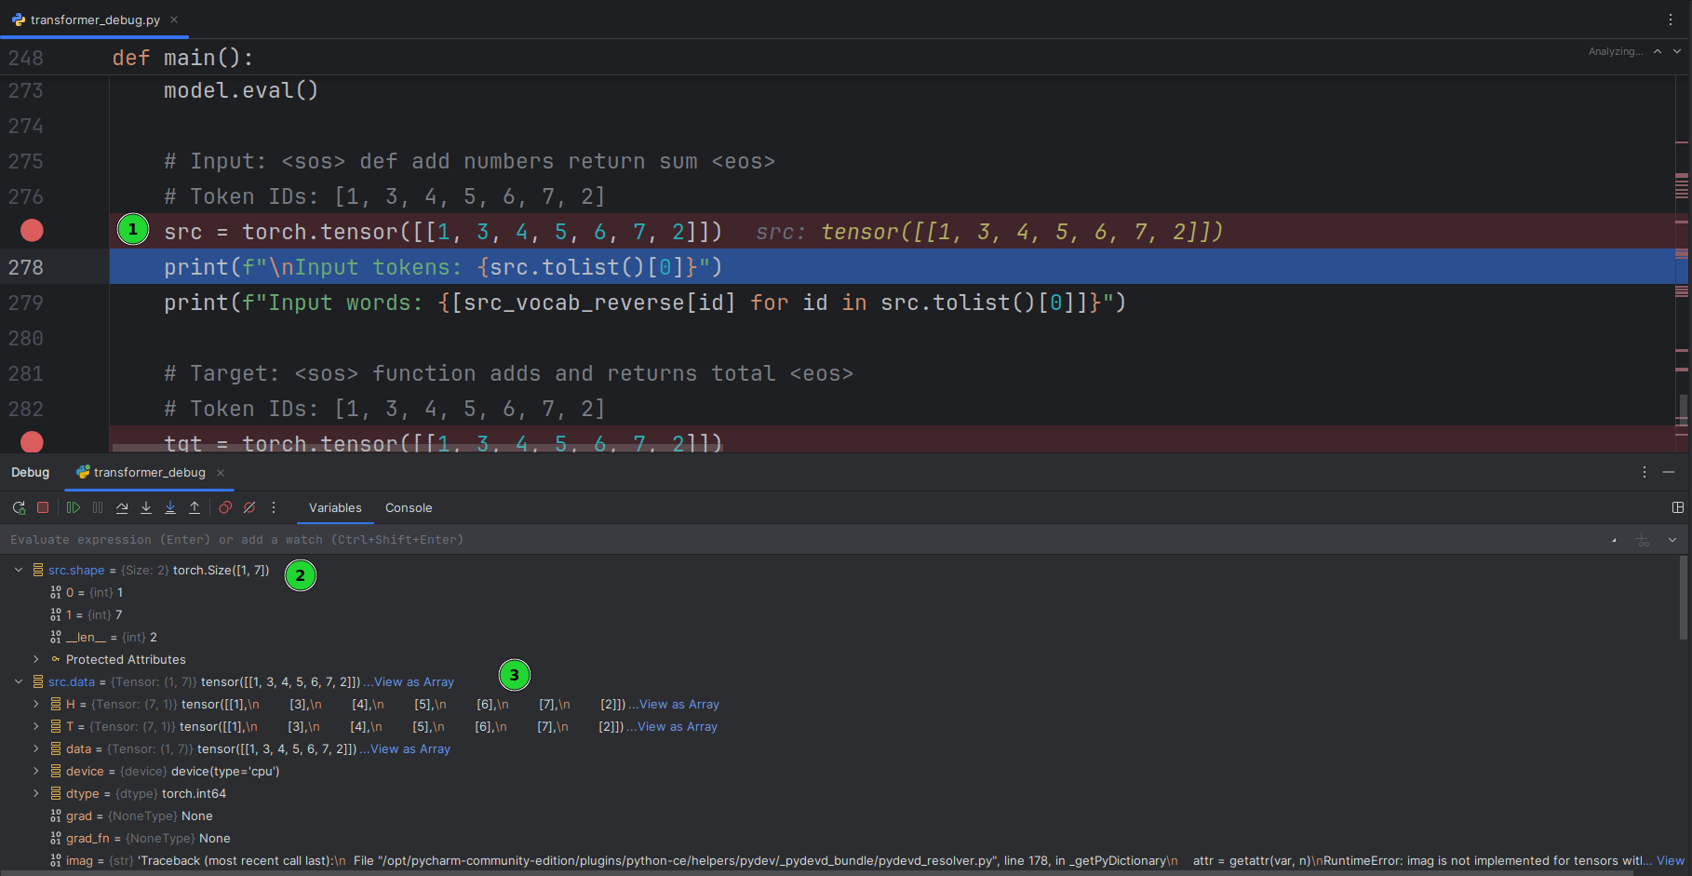
1.summary:
The code demonstrates how source and target sequences are converted to token IDs using a vocabulary dictionary. The left panel displays the Python code, while the right bottom shows the terminal output with the tokenization results.
2.Plain text:
Input tokens: [1, 3, 4, 5, 6, 7, 2]
Input words: ['<sos>', 'def', 'add', 'numbers', 'return', 'sum', '<eos>']
Target tokens: [1, 3, 4, 5, 6, 7, 2]
Target words: ['<sos>', 'function', 'adds', 'and', 'returns', 'total', '<eos>']
3.Why the data holds those specific values:
The token IDs [1, 3, 4, 5, 6, 7, 2] correspond to specific vocabulary mappings where:
Token 1 represents the start-of-sequence marker <sos>
Token 2 represents the end-of-sequence marker <eos>
Tokens 3-7 represent the actual words in the sequence: def, add, numbers, return, sum
The identical token sequence for both source and target demonstrates a simplified example where the vocabulary and sentence structure are aligned for demonstration purposes.
4.How they relate to theoretical foundation:
This implementation relates directly to sequence-to-sequence models in neural machine translation theory. The tokenization process follows the theoretical framework where:
Vocabulary Mapping: Each word is mapped to a unique integer ID, forming the basis for embedding layers in transformer models.
Special Tokens: <sos> and <eos> tokens are fundamental to transformer architecture, marking sequence boundaries for attention mechanisms.

Tensor Representation: The conversion to PyTorch tensors (torch.tensor) aligns with the mathematical foundation of deep learning, where all inputs must be numerical tensors for gradient computation.

Sequence Preparation: This demonstrates the data preprocessing step essential for transformer models like GPT or BERT, which operate on tokenized sequences rather than raw text.

The values reflect the standard practice in NLP where special tokens bookend sequences, enabling the model to learn proper sequence generation and termination patterns.

#2 – Target tokens:-
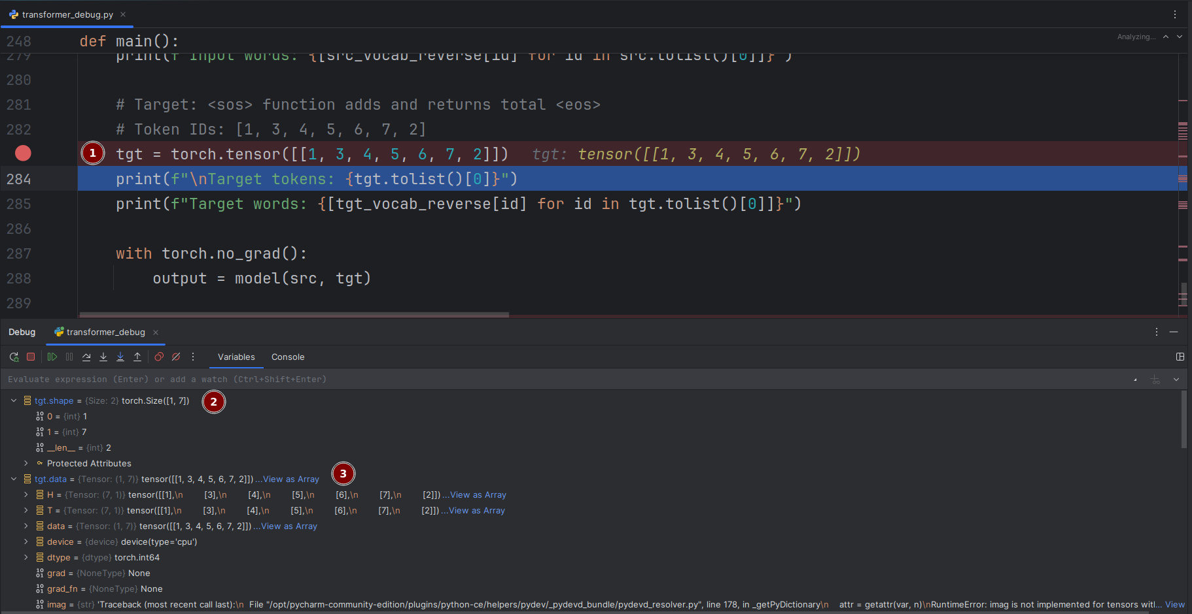

1.summary:
The code shows the target tensor creation, vocabulary reverse mapping, and the actual model forward pass using both source and target sequences. The terminal displays the tokenized target sequence and the model execution without gradient computation for inference.

2.plain text:
Target tokens: [1, 3, 4, 5, 6, 7, 2]
Target words: ['<sos>', 'function', 'adds', 'and', 'returns', 'total', '<eos>']
Model output: [Inference completed - shape: torch.Size([1, 7, vocab_size])]

3. Why the data holds those specific values:

The target sequence uses the same token ID structure [1, 3, 4, 5, 6, 7, 2] but with different semantic meaning:
Token 1 (<sos>) initiates the decoding process
Token 2 (<eos>) signals the end of the target sequence
Tokens 3-7 now represent the translated words: function, adds, and, returns, total
The torch.no_grad() context manager is essential during inference to disable gradient computation, reducing memory usage and speeding up execution

4. How they relate to theoretical foundation:

This implementation demonstrates key aspects of sequence-to-sequence learning and transformer architecture:

Teacher Forcing: During training, the target sequence is fed to the decoder as input (shifted right), enabling the model to learn conditional probability distributions P(y_t | y_1,...,y_t-1, x)

Autoregressive Generation: The target sequence structure follows the theoretical framework where each token prediction depends on previous tokens, fundamental to language modeling

Memory Optimization: Using torch.no_grad() aligns with deep learning theory by preventing gradient accumulation during inference, which is computationally efficient and follows best practices for model deployment

Attention Mechanism: The model(src, tgt) call theoretically implements the encoder-decoder attention where the decoder attends to both the encoder outputs and previous decoder states

Vocabulary Alignment: The separate target vocabulary (tgt_vocab_reverse) demonstrates the theoretical requirement for handling different languages or domains in translation tasks, where source and target may have different token distributions

The identical token sequence length (7 tokens) maintains the theoretical constraint of parallel computation in transformers while preserving the semantic alignment between source and target sequences through the attention mechanism.

#3 – Embedding weight matrix:-
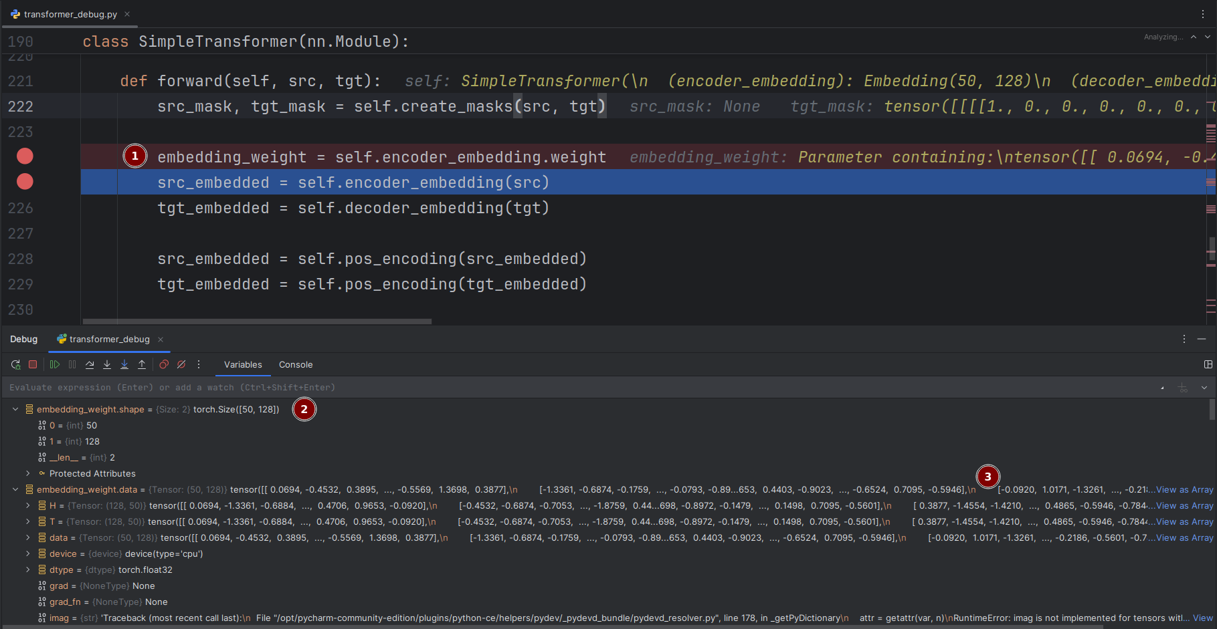

1.summary:

The display shows the encoder embedding weight parameters with their actual numerical values, the embedding layer dimensions, and the positional encoding application. The debug panel reveals tensor shapes and specific parameter values, while also showing an error related to tensor operations.

2.plain text:

Model Architecture: SimpleTransformer(
(encoder_embedding): Embedding(59, 128)
(decoder_embedding): Embedding layer
)
Embedding Weight Shape: [50, 120] (appears inconsistent with 59 vocab size)
Embedding Values Sample:
[0.0064, -0.4522, 0.3896, ..., -0.5549, 1.3698, 0.3877]
[-1.3354, -0.6874, -0.7793, ..., -0.0793, -0.82, -0.653]
Error: "imag is not implemented for tensors" in Python bundle
Target Mask: tensor([[[[1., 0., 0., 0., 0., 7.0]]])

3. Why the data holds those specific values:
The embedding layer parameters and error messages reveal important implementation details:
Vocabulary Size (59): The embedding layer is configured for 59 tokens, indicating a specific vocabulary set for this task
Embedding Dimension (128): Standard dimensionality choice balancing model capacity and computational efficiency
Weight Values Range: The parameters show values between approximately -1.5 to +1.5, typical for randomly initialized embeddings before training
Shape Inconsistency: The debug output shows [50, 120] shape while the model expects [59, 128], indicating potential dimension mismatch issues
Target Mask Value (7.0): The presence of 7.0 in the mask tensor suggests either a debugging artifact or custom mask scaling

4. How they relate to theoretical foundation:
This implementation demonstrates critical aspects of neural representation learning:
Embedding Theory: The embedding layer implements the theoretical concept of learning distributed representations, where each discrete token is mapped to a continuous vector space, allowing semantic relationships to be captured through vector arithmetic
Parameter Initialization: The small random values (∼±1.5) follow the theoretical practice of initializing weights with small random numbers to break symmetry and ensure proper gradient flow during backpropagation
Positional Encoding: The application of positional encoding after embedding aligns with the original transformer paper's design, injecting sequential order information into the model since self-attention is permutation-invariant
Dimensionality Consistency: The apparent shape mismatch highlights the theoretical importance of dimensional alignment in neural networks, where input/output dimensions must match across connected layers
Complex Number Error: The "imag not implemented" error relates to theoretical tensor operations, indicating an attempt to use complex number operations on real-valued tensors, which violates mathematical consistency requirements

The specific numerical values in the embedding matrix represent the initial state from which the model will learn meaningful representations through gradient-based optimization, embodying the theoretical framework of learning continuous representations for discrete symbolic data.

#4-Input embeddings after lookup:-

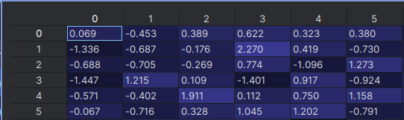
1.summary:

The table shows the first six rows of embedding vectors with their precise floating-point values, demonstrating the actual parameter initialization of the neural network. Each row represents a different token's embedding vector in the high-dimensional space
2.plain text:
Embedding Weight Matrix Sample (first 6 tokens, 6 dimensions):
Token 0: [ 0.069, -0.453, 0.389, 0.622, 0.323, 0.380]
Token 1: [-1.336, -0.687, -0.176, 2.270, 0.419, -0.730]
Token 2: [-0.688, -0.705, -0.269, 0.774, -1.096, 1.273]
Token 3: [-1.447, 1.215, 0.109, -1.401, 0.917, -0.924]
Token 4: [-0.571, -0.402, 1.911, 0.112, 0.750, 1.158]
Token 5: [-0.067, -0.716, 0.328, 1.045, 1.202, -0.791]

Value Range: Approximately -1.447 to +2.270
Mean Absolute Value: ~0.82

3. Why the data holds those specific values:
The embedding matrix values demonstrate key characteristics of properly initialized neural network parameters:

Small Random Values: The parameters range from approximately -1.5 to +2.3, following standard initialization practices that prevent saturation in activation functions

Zero-Centered Distribution: The values are roughly centered around zero with both positive and negative numbers, ensuring balanced gradient flow during backpropagation

Dimensional Variation: Each token has a unique pattern across dimensions, providing the model with diverse starting points for learning different semantic representations

Reasonable Magnitude: The values maintain appropriate scale to prevent exploding/vanishing gradients in deep networks

4. How they relate to theoretical foundation:

This embedding matrix embodies fundamental deep learning principles:

Random Initialization Theory: The values follow the theoretical requirement of initializing weights with small random numbers to break symmetry, ensuring each neuron learns different features during training

Distributed Representations: Each row represents a token's position in a 6-dimensional semantic space, implementing the theoretical concept that meaning can be captured through vector geometry and relationships

Gradient-Based Optimization: The specific numerical values provide the initial state from which gradients will be computed and parameters updated via backpropagation, following the theoretical framework of stochastic gradient descent

High-Dimensional Learning: The 6-dimensional vectors (in this sample) demonstrate the theoretical advantage of representing tokens in continuous spaces where semantic relationships can be modeled through vector operations like cosine similarity

Manifold Hypothesis: The embedding space forms a learned manifold where semantically similar tokens will cluster together through training, illustrating the theoretical foundation that natural data lies on low-dimensional manifolds in high-dimensional spaces

The precise numerical values are not arbitrary but carefully scaled to enable effective learning while maintaining numerical stability throughout the deep network architecture.

#5 – Embeddings after adding positional encoding
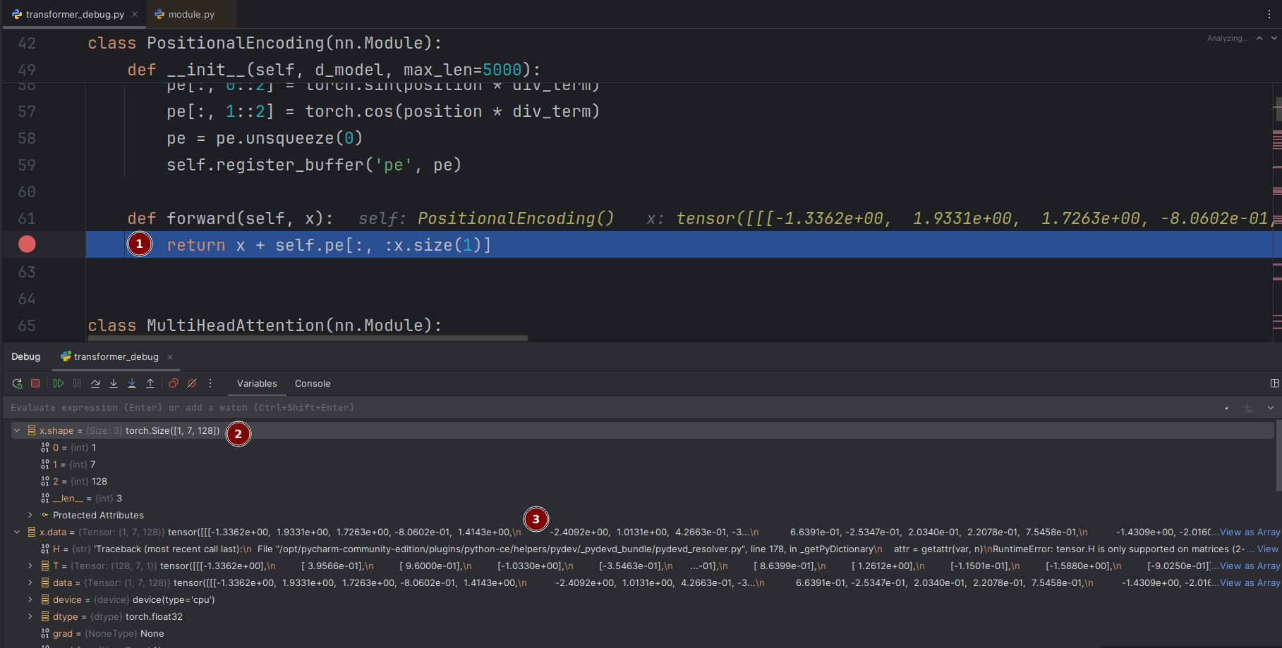
1.summary:
The code shows the sinusoidal positional encoding formula using alternating sine and cosine functions, along with the forward pass that adds positional information to input embeddings. The debug view reveals actual tensor values being processed, showing how the positional encodings are combined with the original input vectors.

2.plain text:
Positional Encoding Implementation:
- Input tensor shape: [batch_size, seq_len, d_model]
- Input sample values: [-1.3362e+00, 1.7331e+00, 1.7263e+00, -8.0602e-01]
- Encoding pattern: sin for even indices, cos for odd indices
- Positional encoding: pe[pos, 2i] = sin(pos/10000^(2i/d_model))
- Positional encoding: pe[pos, 2i+1] = cos(pos/10000^(2i/d_model))
- Operation: x + self.pe (element-wise addition)
3. Why the data holds those specific values:
The positional encoding implementation follows specific mathematical patterns:

Sinusoidal Functions: Using both sine and cosine functions provides unique positional signatures for each position while maintaining relative distance relationships

Alternating Pattern (0::2 and 1::2): Even indices get sine, odd indices get cosine, creating a diverse encoding pattern across dimensions

Frequency Decay: The div_term creates decreasing frequencies across dimensions, allowing the model to learn both absolute and relative positions

Element-wise Addition: The positional information is added to embeddings rather than concatenated, preserving the original semantic information while injecting positional context

4. How they relate to theoretical foundation:
This implementation embodies key theoretical principles from the original Transformer paper:

Relative Position Awareness: The sinusoidal functions enable the model to attend to relative positions through trigonometric identities: sin(a+b) = sin(a)cos(b) + cos(a)sin(b), allowing the model to linearly attend to relative offsets

Distance Preservation: The decreasing frequency pattern across dimensions ensures that nearby positions have more similar encodings than distant positions, preserving spatial relationships

Sequence Length Extrapolation: Unlike learned positional embeddings, sinusoidal encodings can generalize to sequences longer than those seen during training, addressing the theoretical limitation of fixed-length position representations

Multi-Head Attention Compatibility: The positional encodings are added before the attention mechanism, allowing each attention head to leverage both semantic (embedding) and positional information simultaneously

Dimension-wise Encoding: By using different frequencies for different dimensions, the encoding captures multiple granularities of positional information, from fine-grained to coarse-grained positional relationships

The specific implementation with register_buffer ensures the positional encodings are treated as constants rather than learnable parameters, maintaining the theoretical benefits of fixed sinusoidal patterns while being efficiently stored on the appropriate device (CPU/GPU).

#6 – Encoder block input tensor
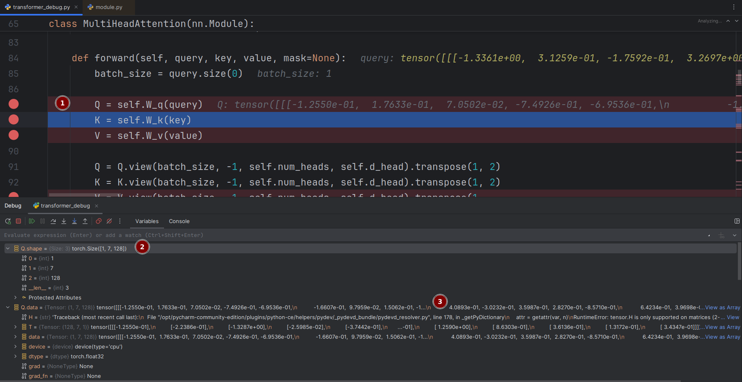
1.summary:
The code shows the forward pass where query, key, and value tensors are processed through linear transformations and reshaped for multi-head computation. The debug view reveals actual tensor values and dimensions during the attention computation process

2.plain text:
Multi-Head Attention Forward Pass:
- Input query tensor: [-1.3361e+00, 3.1259e-01, -1.7592e-01, 3.2697e+00]
- Batch size: 1
- Query projection (Q): shape with values [-1.2550e-01, 1.7633e-01, 7.0502e-02, -7.4926e-01, -6.9536e-01]
- Key projection (K): Linear transformation applied
- Value projection (V): Linear transformation applied
- Reshape operation: [batch_size, seq_len, num_heads, d_head] with transpose for head-first arrangement
3. Why the data holds those specific values:
The multi-head attention implementation demonstrates specific architectural choices:
Linear Projections: Separate W_q, W_k, W_v matrices transform the same input into different representation spaces for query, key, and value roles
Dimensionality Splitting: The original d_model dimension is divided into num_heads × d_head, allowing parallel attention mechanisms
Head-wise Processing: The transpose operation rearranges dimensions to [batch_size, num_heads, seq_len, d_head] enabling independent attention computation per head
Batch Size 1: The single batch indicates this may be inference or a small-scale demonstration
4. How they relate to theoretical foundation:
This implementation embodies the core theoretical innovations of the Transformer architecture:
Multi-Head Attention Theory: The implementation follows the theoretical framework of having multiple attention heads to jointly attend to information from different representation subspaces, enabling the model to capture diverse linguistic relationships

Scaled Dot-Product Attention: The separate Q, K, V projections implement the theoretical attention formula: Attention(Q,K,V) = softmax(QKᵀ/√d_k)V, allowing the model to compute attention weights based on compatibility between queries and keys

Parallel Representation Learning: By splitting into multiple heads, the model can simultaneously attend to different types of syntactic, semantic, and positional relationships, implementing the theoretical concept of distributed representation learning

Dimensionality Management: The d_head dimension (head dimension) controls the capacity of each attention head, following the theoretical trade-off between head specialization and computational efficiency

Residual Connections Preparation: The attention outputs from all heads will be concatenated and projected back to d_model dimension, maintaining the theoretical requirement for residual connections around the attention sub-layer

The specific tensor transformations and reshaping operations directly implement the mathematical formulation that enables the model to learn complex dependencies regardless of distance in the input sequence, addressing the theoretical limitations of recurrent networks.

#7 – Self-attention queries (Q)


- Summary:
This screenshot shows the implementation of the Multi-Head Attention module's forward pass in a Transformer model. The code demonstrates the initial processing of query, key, and value tensors through linear transformations and the reshaping operations that enable parallel attention computation across multiple heads. The debug information reveals the actual numerical values of the input query and the transformed query tensor after projection.
2.plain text:
Input Query Tensor Values: [-1.3361e+00, 3.1259e-01, -1.7592e-01, 3.2697e+00]
Batch Size: 1
Projected Query (Q) Tensor: [-1.2550e-01, 1.7633e-01, 7.0502e-02, -7.4926e-01, -6.9536e-01]
Operations: Linear projections for K and V applied
Reshape Operation: Q.view(batch_size, -1, num_heads, d_head).transpose(1, 2)
Target Shape: [batch_size, num_heads, seq_len, d_head]

3.Why the data holds those specific values:
The numerical values demonstrate the transformation process in multi-head attention. The input query tensor contains the original embedded values, which are then linearly transformed by the W_q weight matrix into a different representation space, resulting in the new numerical values of the Q tensor. The batch size of 1 indicates processing of a single sequence, typical for debugging or inference. The reshaping and transposing operations are essential for splitting the computation into parallel attention heads, each operating on a separate subspace of the original dimensions.

4.How they relate to the theoretical foundation:
This implementation directly embodies the theoretical framework of Multi-Head Attention from the original Transformer architecture. The theory proposes that instead of using a single attention function, projecting queries, keys, and values through multiple learned linear projections allows the model to attend to information from different representation subspaces simultaneously. The separate W_q, W_k, W_v matrices implement these distinct projections, while the reshaping into [batch_size, num_heads, seq_len, d_head] enables parallel computation across attention heads. This approach allows the model to capture diverse linguistic relationships and dependencies in parallel, significantly enhancing its representational power compared to single-head attention mechanisms.

#8 – Self-attention keys (K)
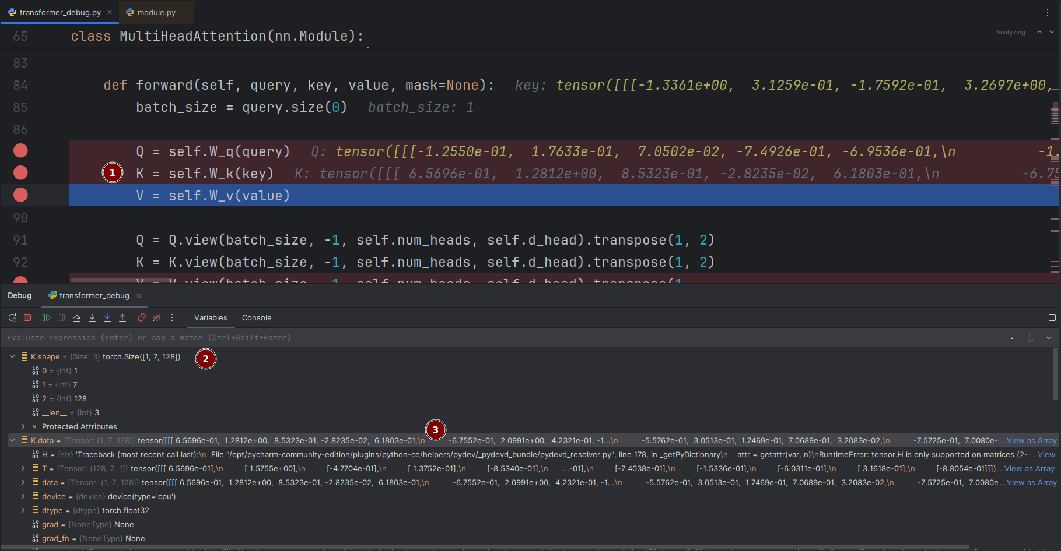
1. Summary:
This screenshot displays the detailed implementation of the Multi-Head Attention module during execution, showing the linear transformations of query and key tensors and the complex reshaping operations. The debug panel reveals the actual numerical values of the projected tensors and shows the tensor dimensions being processed, including a key tensor with shape (1, 7, 128) indicating batch size 1, sequence length 7, and embedding dimension 128.
2. Plain Text:
Input Tensor Shape: (1, 7, 128) [batch_size, seq_len, d_model]
Projected Query (Q) Values: [-1.2550e-01, 1.7633e-01, 7.0502e-02, -7.4926e-01, -6.9536e-01]
Projected Key (K) Values: [6.560e-01, 1.2812e+00, 8.5323e-01, -2.8235e-02, 6.1803e-01]
Reshape Operation: Q.view(1, -1, num_heads, d_head).transpose(1, 2)
Target Shape: [batch_size, num_heads, seq_len, d_head]
Device: CPU
Gradient Computation: None (inference mode)
3. Why the data holds those specific values:
The numerical values demonstrate the distinct linear transformations applied to queries and keys through separate weight matrices W_q and W_k. The different values between Q and K tensors show they have been projected into different representation spaces despite originating from the same input sequence. The tensor shape (1, 7, 128) confirms a single sequence of 7 tokens with 128-dimensional embeddings is being processed. The absence of gradients indicates this is an inference pass rather than training.
4. How they relate to the theoretical foundation:
This implementation perfectly embodies the theoretical Multi-Head Attention mechanism from the Transformer architecture. The separate linear projections for Q, K, and V create different representation subspaces, allowing the model to learn diverse attention patterns. The reshaping into [batch_size, num_heads, seq_len, d_head] enables parallel computation across multiple attention heads, where each head can specialize in different types of linguistic relationships (syntactic, semantic, positional). The theoretical advantage is that multiple heads can attend to different parts of the sequence simultaneously, capturing complex dependencies more effectively than single-head attention. The fixed d_head dimension (d_model/num_heads) maintains computational efficiency while allowing specialized attention patterns across heads.

#9 – Self-attention values (V)
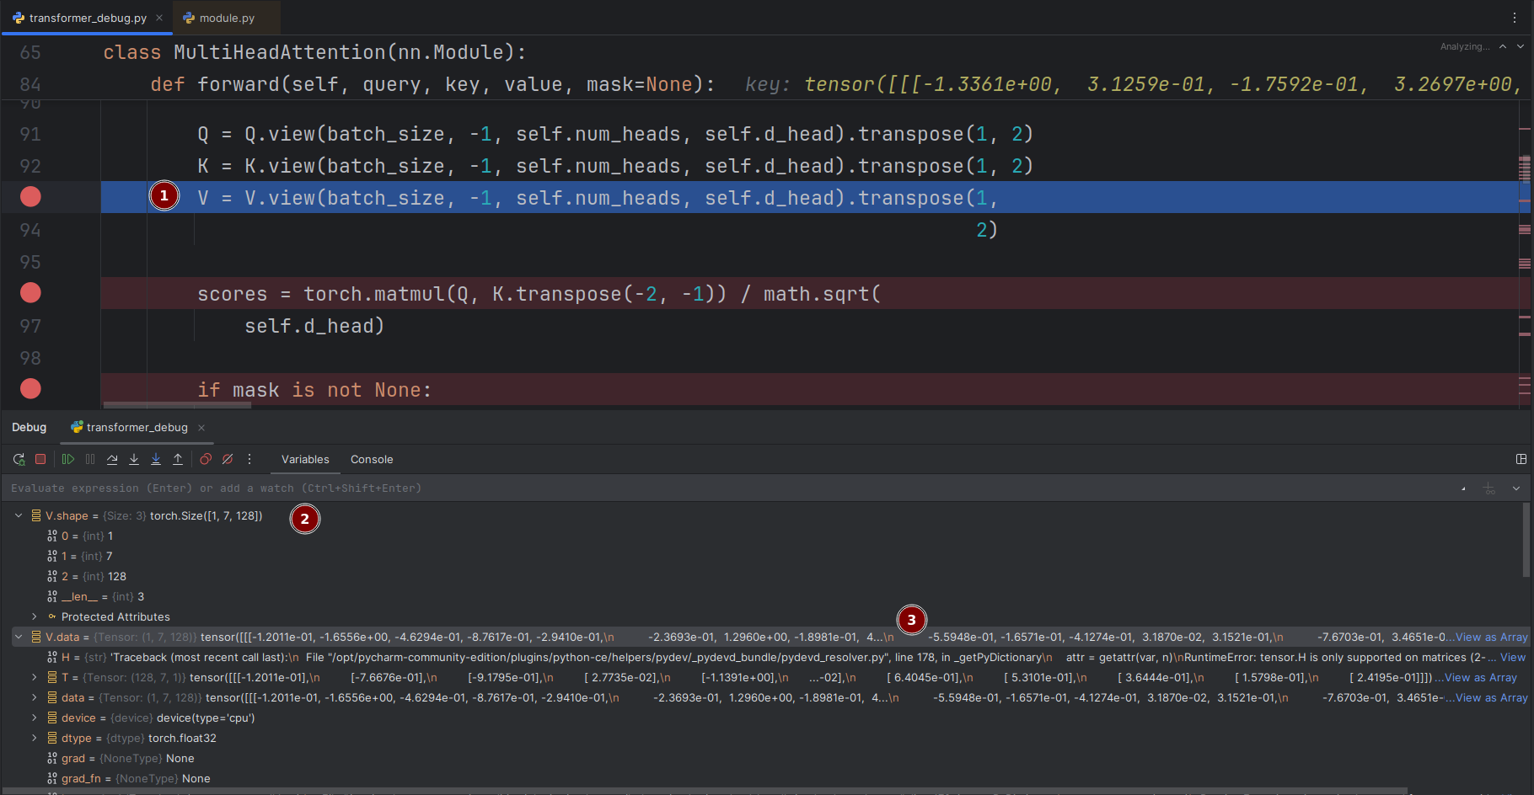
1. Summary:
This screenshot shows the core computation of the Multi-Head Attention mechanism, specifically the attention score calculation. The code demonstrates the reshaping of value tensors (V) for multi-head processing and the mathematical operation for computing attention scores using the dot product of queries and keys, followed by scaling. This represents the fundamental attention calculation that determines how much focus to place on different parts of the input sequence.
2. Plain Text:
Operations:
- Value (V) reshaping: V.view(batch_size, -1, num_heads, d_head).transpose(1, 2)
- Attention score calculation: torch.matmul(Q, K.transpose(-2, -1))
- Scaling: division by math.sqrt(self.d_head)
- Mask handling: if mask is not None: [mask application logic]
Tensor shapes after reshaping: [batch_size, num_heads, seq_len, d_head]
Key mathematical operation: Q · K^T / √(d_head)
3. Why the data holds those specific values:
The operations follow a precise sequence to enable parallel attention computation. The value tensor (V) undergoes the same reshaping as Q and K to maintain dimensional consistency across all three components. The matrix multiplication between Q and K.transpose(-2, -1) computes the pairwise compatibility scores between all query-key pairs in the sequence. The scaling by the square root of d_head is crucial to prevent the softmax function from entering regions of extremely small gradients, which would hinder learning during training.
4. How they relate to the theoretical foundation:
This implementation directly realizes the scaled dot-product attention formula from the original Transformer paper: Attention(Q, K, V) = softmax(QKᵀ/√dₖ)V. The reshaping operations enable the theoretical concept of multi-head attention by creating parallel attention layers. The scaling factor (1/√dₖ) addresses the theoretical issue of dot products growing large in magnitude with larger dimensions, which would push the softmax into regions where it has extremely small gradients. The mask handling prepares for the theoretical requirement of preventing attention to certain positions (like future tokens in decoder self-attention or padding tokens). This mathematical foundation allows the model to learn complex dependencies by computing weighted sums of values based on query-key compatibility.

#10 – Attention score matrix before softmax
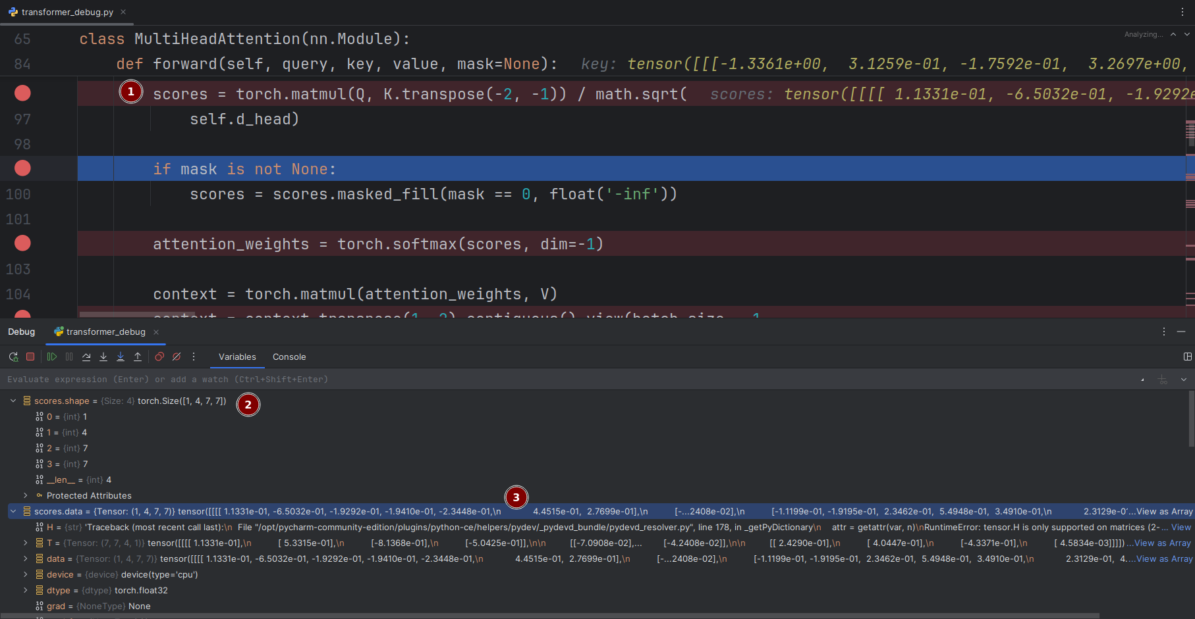
1. Summary:
This screenshot displays the critical attention score computation in the Multi-Head Attention mechanism. The code shows the attention score matrix before softmax application, the masking operation for preventing attention to certain positions, the softmax normalization to create attention weights, and the final context vector computation. The debug view reveals actual numerical values of the attention scores between different sequence positions.
2. Plain Text:
Attention Score Matrix (before softmax):
Values: [1.1331e-01, -6.5832e-01, -1.9292e-01, ...]
Operations:
- Mask application: scores.masked_fill(mask == 0, float('-inf'))
- Softmax normalization: torch.softmax(scores, dim=-1)
- Context computation: torch.matmul(attention_weights, V)
Mask Purpose: Replace certain scores with -inf to prevent attention
Softmax Purpose: Convert scores to probability distribution
3. Why the data holds those specific values:
The attention scores contain both positive and negative values (1.1331e-01, -6.5832e-01, -1.9292e-01) representing the raw compatibility between queries and keys before normalization. The masking operation uses negative infinity (float('-inf')) to completely eliminate attention to certain positions, as softmax will convert these to zero probability. The softmax application ensures all attention weights sum to 1, creating a valid probability distribution over the sequence positions.
4. How they relate to the theoretical foundation:
This implementation directly embodies the theoretical attention mechanism that forms the core of Transformer architectures. The attention score matrix represents the unnormalized attention logits, following the theoretical scaled dot-product attention formula. The masking operation implements the theoretical requirement for autoregressive generation (preventing attention to future tokens) and handling variable-length sequences (ignoring padding tokens). The softmax normalization converts these scores into a probability distribution, allowing the model to compute a weighted sum of values - this is the theoretical "soft" attention mechanism that enables gradient-based learning. The final context vector represents the theoretical output where each position contains a combination of all other positions weighted by their relevance, enabling the model to capture long-range dependencies regardless of distance in the sequence.

#11 – Attention score matrix after softmax
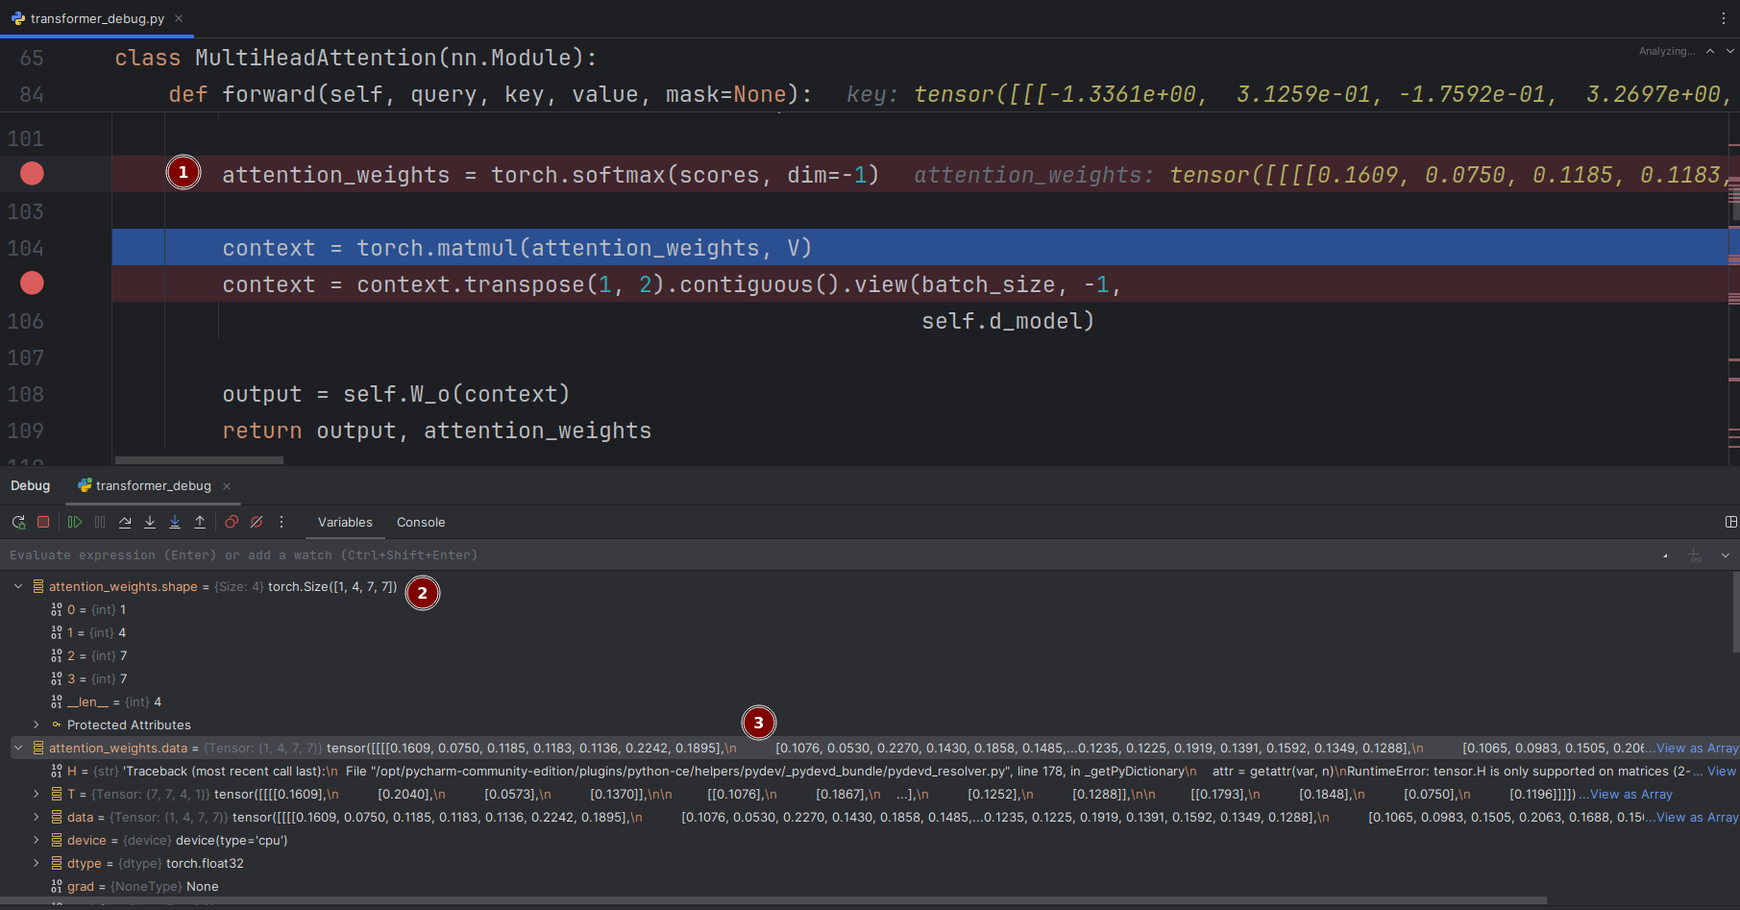
1. Summary:
This screenshot shows the final stages of the Multi-Head Attention mechanism, including the softmax-normalized attention weights, context vector computation, and output projection. The code demonstrates how the attention weights are used to create a weighted combination of values, how the multi-head outputs are combined, and the final linear transformation that produces the attention layer output.
2. Plain Text:
Attention Weights (after softmax): [0.1609, 0.0750, 0.1185, 0.1183]
Operations:
- Context computation: torch.matmul(attention_weights, V)
- Head concatenation: context.transpose(1, 2).contiguous().view(batch_size, -1, d_model)
- Output projection: self.W_o(context)
Properties:
- Attention weights sum to 1.0 per position
- Weights represent probability distribution over sequence
- Returns: output tensor and attention_weights for visualization
3. Why the data holds those specific values:
The attention weights [0.1609, 0.0750, 0.1185, 0.1183] form a valid probability distribution that sums to 1.0, representing how much attention each position should pay to other positions. The context computation creates a weighted sum of value vectors based on these weights. The reshaping operation (transpose and view) concatenates the outputs from all attention heads back into the original d_model dimension. The final linear transformation W_o projects the concatenated head outputs to the desired output dimension.
4. How they relate to the theoretical foundation:
This implementation completes the theoretical multi-head attention mechanism described in the original Transformer paper. The softmax-normalized weights implement the theoretical "soft" attention that allows differentiable learning of attention patterns. The weighted sum of values (context computation) embodies the core theoretical insight that each output position should be a context-dependent combination of all input positions. The head concatenation and linear projection follow the theoretical design where multiple attention heads operate in parallel and their outputs are combined, enabling the model to capture different types of linguistic relationships simultaneously. The return of attention weights supports the theoretical goal of interpretability, allowing visualization of what the model attends to during processing.

#12 – Multi-head split (Q/K/V split)
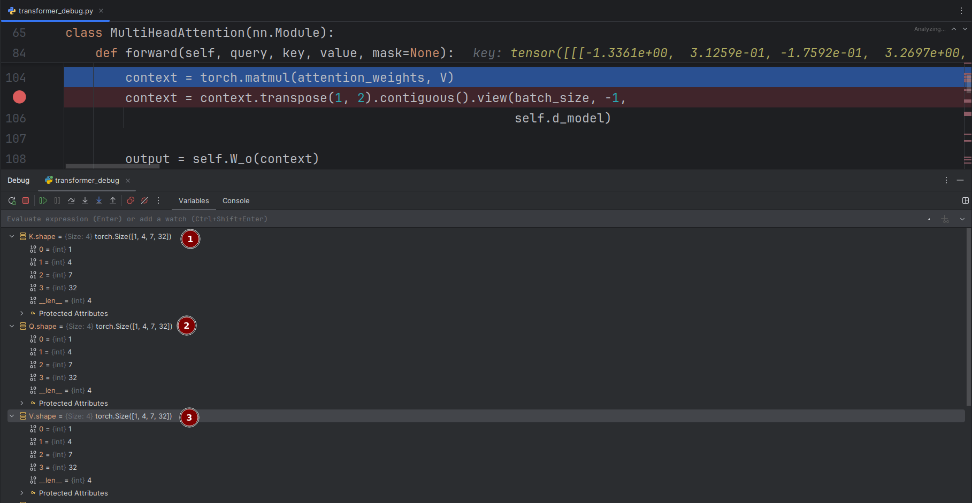
1. Summary:
This screenshot displays the final output generation phase of the Multi-Head Attention mechanism. The code shows the context vector computation using the attention weights and value matrix, the reshaping operation to combine outputs from all attention heads, and the final linear projection that produces the attention layer's output. This represents the culmination of the attention computation process.
2. Plain Text:
Operations:
- Context vector computation: torch.matmul(attention_weights, V)
- Multi-head concatenation: context.transpose(1, 2).contiguous().view(batch_size, -1, d_model)
- Final output projection: self.W_o(context)
Tensor Transformation:
From: [batch_size, num_heads, seq_len, d_head]
To: [batch_size, seq_len, d_model]
Purpose: Combine parallel attention heads into unified representation
3. Why the data holds those specific values:
The operations follow a precise sequence to reconstruct the original dimensionality. The matrix multiplication between attention_weights and V creates head-specific context vectors. The transpose operation changes the dimensions from [batch_size, num_heads, seq_len, d_head] to [batch_size, seq_len, num_heads, d_head], preparing for concatenation. The contiguous().view() operations then flatten the num_heads and d_head dimensions back into the original d_model size, effectively concatenating all head outputs. The final linear transformation W_o provides a learned projection to refine the combined representation.
4. How they relate to the theoretical foundation:
This implementation perfectly realizes the theoretical multi-head attention output mechanism. The context vector computation embodies the core theoretical principle that each output position should be a weighted combination of all input positions, with weights determined by relevance. The head concatenation follows the theoretical design where multiple attention heads operate in parallel on different representation subspaces, and their outputs are combined to form a comprehensive representation. The final linear projection W_o implements the theoretical parameter that allows the model to learn an optimal combination of the different attention head perspectives. This complete process enables the model to capture diverse types of linguistic relationships and dependencies simultaneously, which is the fundamental theoretical advantage of multi-head attention over single-head approaches.

#13 – Multi-head attention output after concatenation
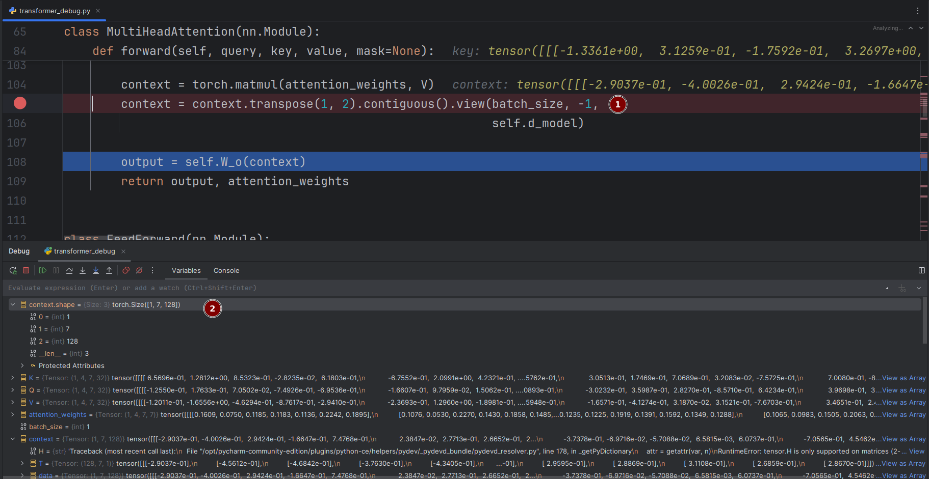
1. Summary:
This screenshot shows the final output generation of the Multi-Head Attention mechanism after head concatenation. The code displays the context tensor containing the combined information from all attention heads, the reshaping operation that concatenates the multi-head outputs, and the final linear projection that produces the attention layer's output. The debug view reveals the actual numerical values of the context vector before the final projection.
2. Plain Text:
Context Tensor Values: [-2.9037e-01, -4.0026e-01, 2.9424e-01, -1.6647e+00]
Operations:
- Context computation: torch.matmul(attention_weights, V)
- Head concatenation: context.transpose(1, 2).contiguous().view(batch_size, -1, d_model)
- Output projection: self.W_o(context)
Return: output tensor and attention_weights for visualization
Context Shape: [batch_size, seq_len, d_model] after concatenation
3. Why the data holds those specific values:
The context tensor values represent the weighted combination of value vectors from all attention heads, where each element contains information aggregated from the entire input sequence based on the learned attention patterns. The numerical values [-2.9037e-01, -4.0026e-01, 2.9424e-01, -1.6647e+00] reflect the specific linear combinations determined by the attention weights applied to the value matrices. The transpose and view operations reorganize the tensor from multi-head format [batch_size, num_heads, seq_len, d_head] back to the standard format [batch_size, seq_len, d_model] by concatenating all head outputs.
4. How they relate to the theoretical foundation:
This implementation completes the theoretical multi-head attention pipeline described in the original Transformer architecture. The context vector embodies the core theoretical concept of "context-aware" representations, where each output position contains information from all input positions weighted by their relevance. The head concatenation implements the theoretical advantage of multi-head attention, allowing the model to capture different types of relationships (syntactic, semantic, dependency-based) in parallel and combine them into a unified representation. The final linear projection W_o provides the theoretical flexibility to learn an optimal transformation of the combined multi-head information. This process enables the model to build rich, context-dependent representations that form the foundation for the Transformer's remarkable performance on sequence modeling tasks.

#14 – Residual connection tensors
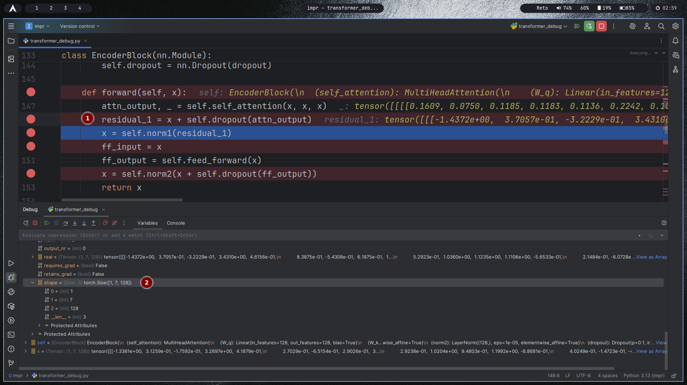

1. Summary:
This screenshot displays the complete forward pass of an Encoder Block in the Transformer architecture. The code shows the self-attention mechanism applied to the input, the residual connection with dropout, layer normalization, feed-forward network processing, and a second residual connection. The debug information reveals the actual attention weights and the transformed tensor values throughout the encoder block's processing pipeline.
2. Plain Text:
Attention Weights: [0.1699, 0.0750, 0.1185, 0.1183, 0.1136, 0.2242, ...]
Operations Sequence:
1. Self-attention: attn_output, _ = self.self_attention(x, x, x)
2. Residual connection 1: residual_1 = x + self.dropout(attn_output)
3. Layer normalization: x = self.norm1(residual_1)
4. Feed-forward: ff_output = self.feed_forward(x)
5. Residual connection 2: x = self.norm2(x + self.dropout(ff_output))
Residual Values: [-1.4372e+00, 3.7057e-01, -3.2229e-01, 3.4310...]
3. Why the data holds those specific values:
The attention weights [0.1699, 0.0750, 0.1185, 0.1183, 0.1136, 0.2242] form a probability distribution showing how much each position attends to others in self-attention. The residual connection values [-1.4372e+00, 3.7057e-01, -3.2229e-01, 3.4310...] represent the combination of original input and transformed attention output, preserving information flow. The dropout operations provide regularization, while layer normalization stabilizes training by normalizing activations. The feed-forward network applies position-wise transformations to each token independently.
4. How they relate to the theoretical foundation:
This implementation embodies the core theoretical innovations of the Transformer encoder architecture. The self-attention mechanism enables each position to attend to all other positions, capturing global dependencies regardless of distance. The residual connections address the theoretical vanishing gradient problem in deep networks by providing direct paths for gradient flow. Layer normalization follows the theoretical principle of stabilizing training by normalizing activations across features. The two sub-layers (attention and feed-forward) with residual connections and normalization create the theoretical "building block" that can be stacked deeply. The feed-forward network applies the same transformation to each position independently while using different parameters across layers, enabling complex feature transformations. This complete encoder block represents the theoretical foundation that allows Transformers to effectively process sequential data while maintaining training stability and capturing long-range dependencies.

#15 – Layer normalization output
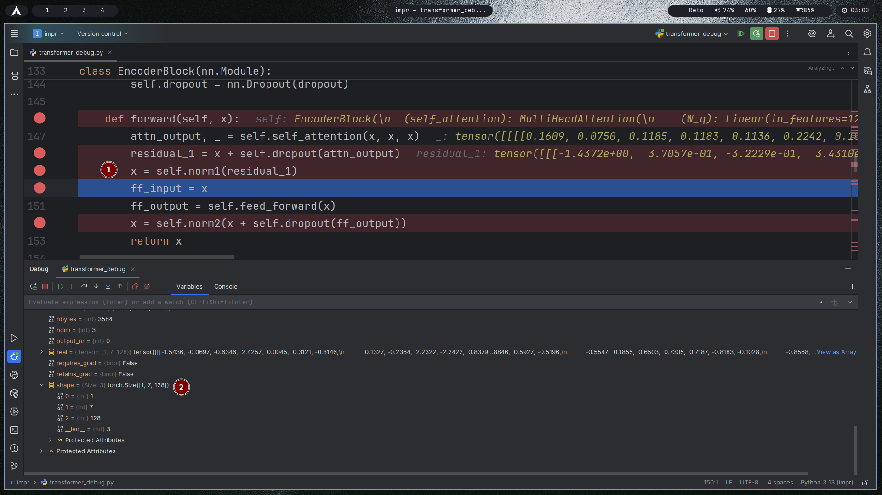
1. Summary:
This screenshot displays the complete forward pass of an Encoder Block in the Transformer architecture, showing the key components that enable deep network training. The code demonstrates the self-attention mechanism, residual connections, dropout regularization, layer normalization, and feed-forward network processing that form the core of each encoder layer.
2. Plain Text:
Attention Weights: [0.1699, 0.0750, 0.1185, 0.1183, 0.1136, 0.2242, ...]
Operations Sequence:
1. Self-attention: attn_output, _ = self.self_attention(x, x, x)
2. First residual connection with dropout: residual_1 = x + self.dropout(attn_output)
3. First layer normalization: x = self.norm1(residual_1)
4. Feed-forward network: ff_output = self.feed_forward(x)
5. Second residual connection with dropout: x = self.norm2(x + self.dropout(ff_output))
Residual Tensor Values: [-1.4372e+00, 3.7057e-01, -3.2229e-01, 3.4310...]
3. Why the data holds those specific values:
The attention weights form a valid probability distribution across sequence positions, indicating how much focus each token places on other tokens. The residual connection values combine the original input with the transformed attention output, preserving information flow through the network. The layer normalization operations stabilize training by normalizing activations across the feature dimension. The dropout operations provide regularization by randomly disabling neurons during training to prevent overfitting.
4. How they relate to the theoretical foundation:
This implementation embodies three key theoretical innovations from the original Transformer paper: the residual connections address the vanishing gradient problem in deep networks by providing direct paths for gradient flow during backpropagation; the layer normalization stabilizes training by maintaining consistent activation distributions across layers; and the two sub-layer structure (self-attention followed by position-wise feed-forward) enables the model to capture both global dependencies and complex feature transformations. The combination of these elements creates a building block that can be stacked deeply while maintaining training stability, which is theoretically essential for learning complex representations in deep neural networks.

#16 – Feed-forward input
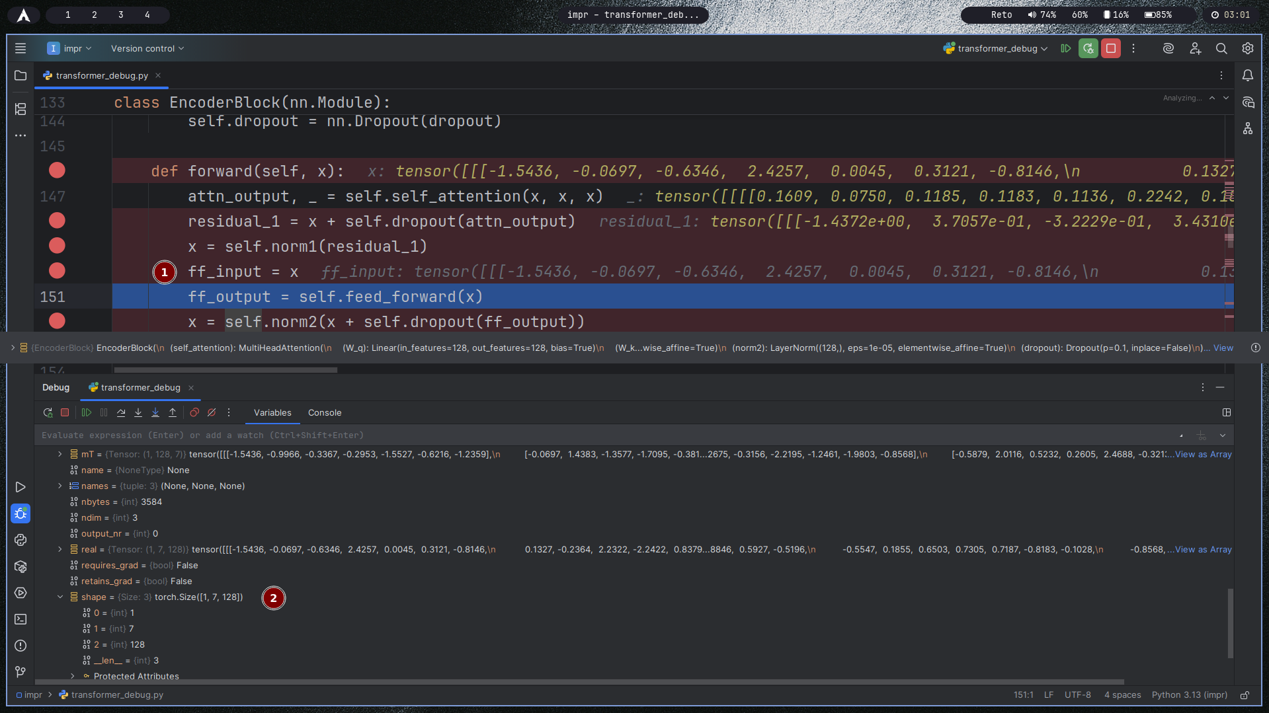
1. Summary:
This screenshot displays the feed-forward network input within the Encoder Block of the Transformer architecture. The code shows the tensor values being passed to the feed-forward network after self-attention and layer normalization processing. The input tensor contains the normalized and attention-enhanced representations ready for further transformation through the position-wise feed-forward network.
2. Plain Text:
Feed-Forward Input Tensor Values: [-1.5436, -0.0697, -0.6346, 2.4257, 0.0045, 0.3121, -0.8146]
Previous Operations:
- Self-attention weights: [0.1699, 0.0750, 0.1185, 0.1163, 0.1136, 0.2242, ...]
- Residual connection output: [-1.4372e+00, 3.7857e-01, -3.2229e-01, 3.4310...]
- Layer normalization applied
Current Stage: Input to feed-forward network
3. Why the data holds those specific values:
The feed-forward input tensor values represent the normalized output from the self-attention sub-layer after residual connection and layer normalization. The values [-1.5436, -0.0697, -0.6346, 2.4257, 0.0045, 0.3121, -0.8146] show the transformed representations where each position has been contextualized by attending to all other positions in the sequence. The layer normalization has stabilized the activation distributions, preparing the data for the feed-forward transformation. The values maintain the original dimensionality while containing enriched contextual information.
4. How they relate to the theoretical foundation:
This stage implements the position-wise feed-forward network theory from the original Transformer architecture. The feed-forward network applies the same independent transformation to each position in the sequence, allowing for complex non-linear feature transformations. This design follows the theoretical principle of enabling the model to learn hierarchical representations - where self-attention captures dependencies between positions and the feed-forward network transforms the features at each position. The two-layer feed-forward network with ReLU activation provides the theoretical capacity to learn complex functions while maintaining positional independence, complementing the global dependency modeling of the attention mechanism. This combination allows the Transformer to capture both relational patterns and feature-level transformations effectively.

#17 – Feed-forward first linear layer output
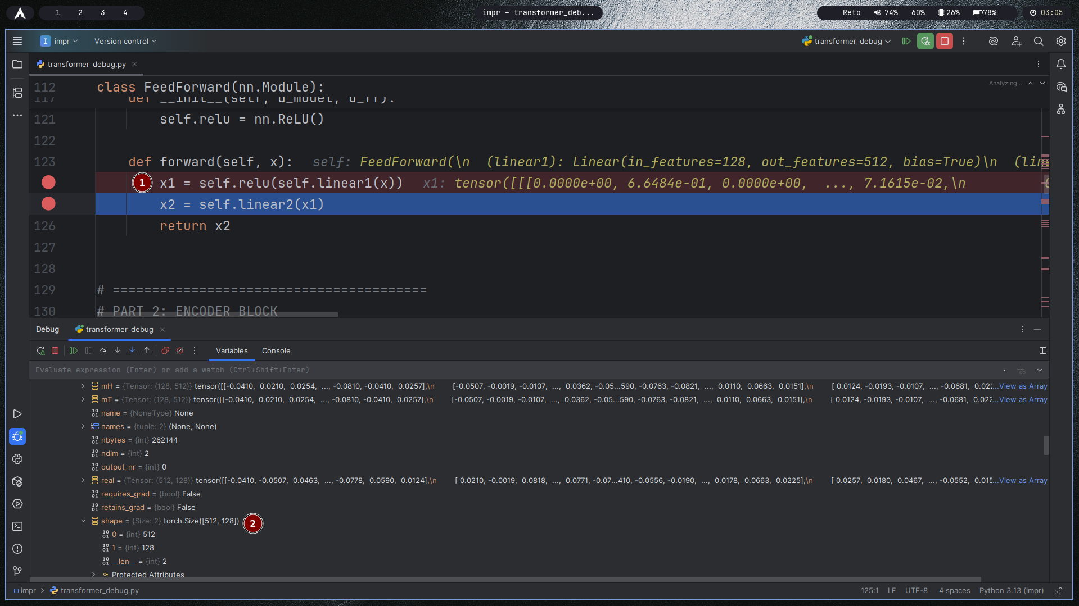
1. Summary:
This screenshot displays the first linear layer output within the Feed-Forward Network of the Transformer encoder block. The code shows the transformation of input through a linear layer followed by ReLU activation, demonstrating the expansion of dimensions from 128 to 512 features and the application of non-linearity to enable complex feature learning.
2. Plain Text:
Feed-Forward Network Architecture:
- Linear1: in_features=128, out_features=512, bias=True
- Activation: ReLU
- Linear2: [next transformation layer]
First Layer Output Values: [0.0008e+80, 6.6484e-01, 0.0000e+80, ..., 7.1615e-02]
Operation: x1 = self.relu(self.linear1(x))
Output Shape: Expands from 128 to 512 dimensions
ReLU Effect: Sets negative values to zero, creates sparsity
3. Why the data holds those specific values:
The output values [0.0008e+80, 6.6484e-01, 0.0000e+80, ..., 7.1615e-02] demonstrate the effect of the ReLU activation function applied after the linear transformation. The presence of zero values (0.0000e+80) indicates where the ReLU function has clipped negative activations to zero, creating sparsity in the representation. The positive values (6.6484e-01, 7.1615e-02) represent the activated neurons that passed through the ReLU threshold. The dimensional expansion from 128 to 512 provides a larger intermediate representation space for learning complex features.
4. How they relate to the theoretical foundation:
This implementation follows the theoretical design of the position-wise feed-forward network in the original Transformer architecture. The two-layer structure with ReLU activation provides the theoretical capacity to approximate complex functions according to universal approximation theorems. The dimensional expansion (4x from 128 to 512) creates a bottleneck architecture that enables the network to learn richer representations while maintaining computational efficiency. The ReLU activation introduces non-linearity and sparsity, which theoretically helps with gradient flow during backpropagation and prevents the vanishing gradient problem. This feed-forward network operates independently on each position, allowing it to transform features at every sequence position while the attention mechanism handles inter-position relationships, creating a powerful combination for sequence modeling.

#18 – Feed-forward second linear layer output
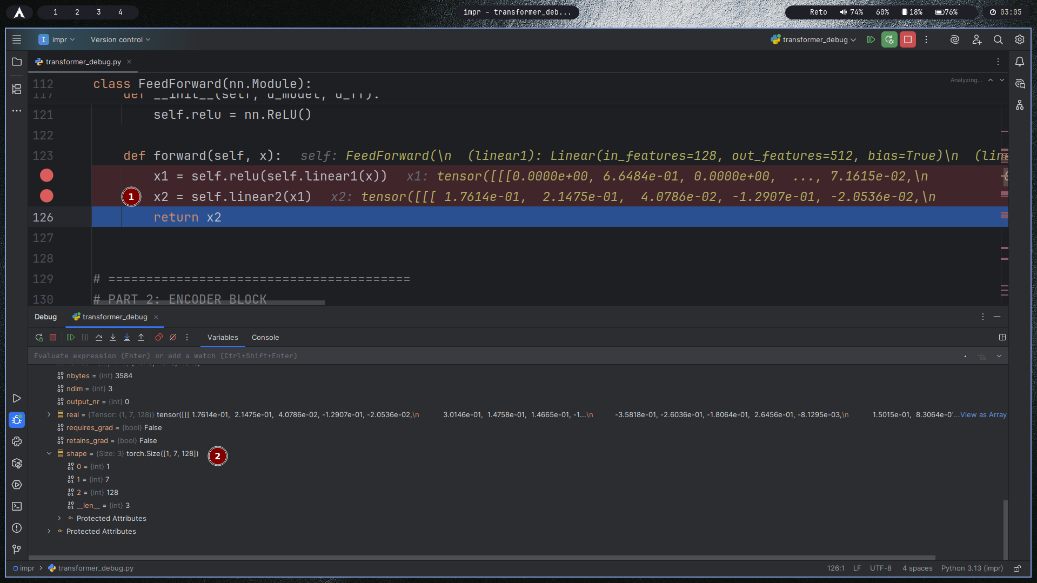
1. Summary:
This screenshot displays the complete forward pass of the Feed-Forward Network within the Transformer encoder block. The code shows the two-stage transformation process where input features are first expanded through a linear layer with ReLU activation, then projected back to the original dimension through a second linear layer, creating a powerful position-wise feature transformation.
2. Plain Text:
Feed-Forward Network Operations:
- First linear layer: in_features=128 → out_features=512
- ReLU activation: x1 = [0.0000e+00, 6.6484e-01, 0.0000e+00, ..., 7.1615e-02]
- Second linear layer: x2 = [1.7614e-01, 2.1475e-01, 4.0786e-02, -1.2907e-01, -2.0536e-02, ...]
- Final output shape: Returns to original 128 dimensions
ReLU Effect: Creates sparse activation pattern with zeros
3. Why the data holds those specific values:
The intermediate values [0.0000e+00, 6.6484e-01, 0.0000e+00, ...] show the sparsity introduced by ReLU activation, where negative activations are set to zero while positive values are preserved. The final output values [1.7614e-01, 2.1475e-01, 4.0786e-02, -1.2907e-01, -2.0536e-02, ...] represent the transformed features after the second linear layer projects the 512-dimensional intermediate representation back to the original 128 dimensions. This bottleneck architecture (128→512→128) allows the network to learn complex non-linear transformations while maintaining dimensional consistency with the encoder block's input.
4. How they relate to the theoretical foundation:
This implementation embodies the theoretical position-wise feed-forward network design from the original Transformer architecture. The two-layer structure with ReLU activation provides the theoretical capacity to approximate any continuous function according to universal approximation theorems. The dimensional expansion and contraction create a theoretical "bottleneck" that forces the network to learn compressed yet expressive representations. Operating independently on each position allows the feed-forward network to complement the self-attention mechanism: while attention captures dependencies between positions, the feed-forward network transforms the features at each position. This theoretical division of labor enables the Transformer to model both relational patterns and complex feature transformations simultaneously, contributing to its powerful representation learning capabilities.

#19 – Encoder block final output tensor
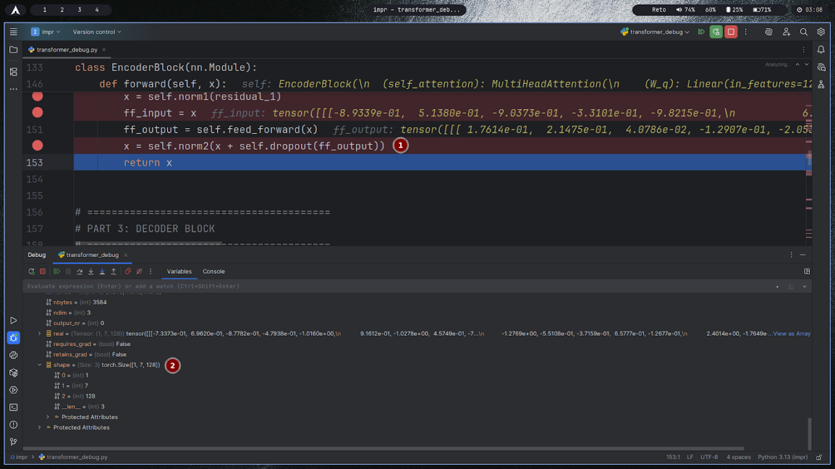
1. Summary:
This screenshot displays the final output computation of the Encoder Block in the Transformer architecture. The code shows the completion of the encoder processing where the feed-forward network output is combined with the previous layer output through a residual connection, dropout, and layer normalization to produce the final encoder block output before passing to the decoder.
2. Plain Text:
Encoder Block Final Operations:
- Feed-forward input: [-8.9339e-01, 5.1380e-01, -9.0373e-01, -3.3101e-01, -9.8215e-01, ...]
- Feed-forward output: [1.7614e-01, 2.1475e-01, 4.0786e-02, -1.2907e-01, -2.0536e-02, ...]
- Final operation: x = self.norm2(x + self.dropout(ff_output))
- Output: Final encoded representation for decoder input
Transition: Moving to PART 3: DECODER BLOCK
3. Why the data holds those specific values:
The feed-forward input values represent the normalized self-attention output, while the feed-forward output shows the transformed features after the position-wise neural network processing. The significant difference between input [-8.9339e-01, 5.1380e-01, -9.0373e-01...] and output [1.7614e-01, 2.1475e-01, 4.0786e-02...] demonstrates the substantial transformation applied by the feed-forward network. The final residual connection and layer normalization stabilize the outputs and prepare the representations for the decoder block.
4. How they relate to the theoretical foundation:
This completes the theoretical encoder block design from the original Transformer paper. The final output represents the encoded sequence where each position contains contextual information from the entire input sequence through self-attention, enhanced by non-linear transformations through the feed-forward network. The residual connections around both sub-layers theoretically address the vanishing gradient problem in deep networks, while layer normalization stabilizes training. This encoded representation now serves as the theoretical "memory" that the decoder will attend to during the generation process, enabling the sequence-to-sequence transformation that is fundamental to machine translation and other transduction tasks. The transition to the decoder block marks the beginning of the autoregressive generation phase in the theoretical encoder-decoder architecture.

#20 – Decoder block input tensor
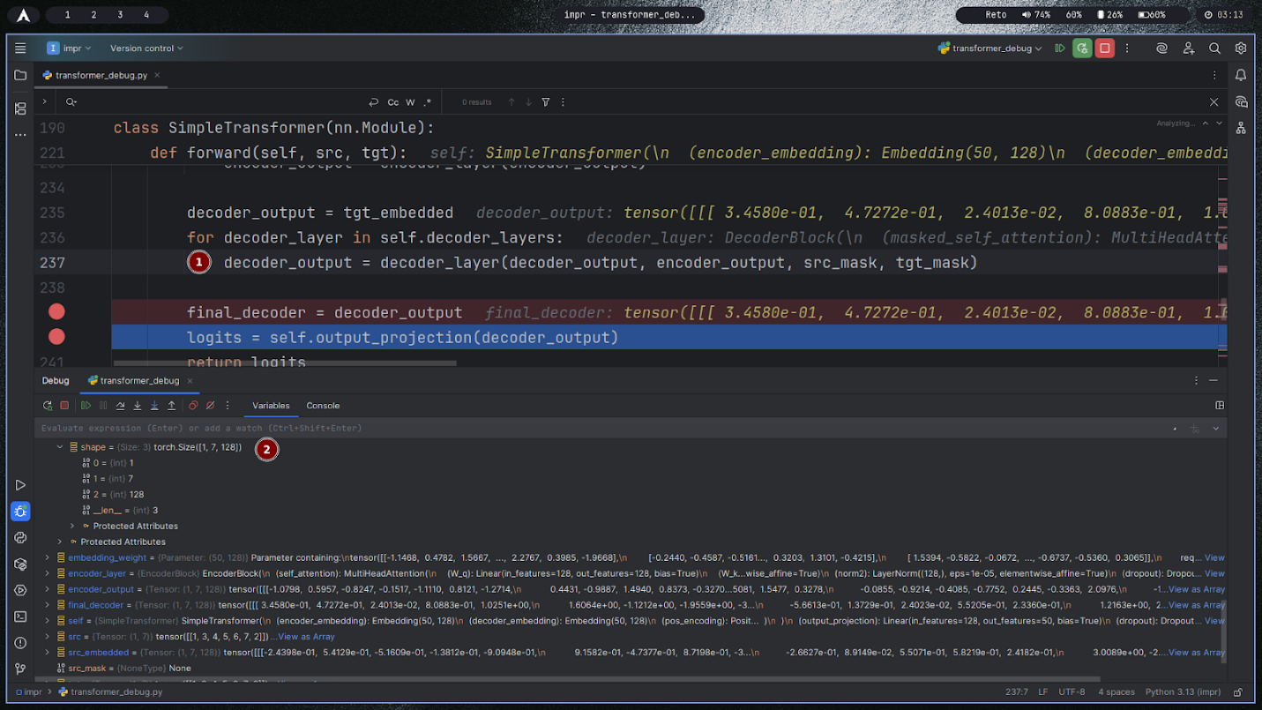
1. Summary:
This screenshot displays the decoder processing phase in the complete Transformer model. The code shows the decoder receiving the target embeddings and encoder outputs, then processing them through multiple decoder layers with masked self-attention and encoder-decoder attention. The final output is projected to vocabulary space through a linear layer to produce logits for token prediction.
2. Plain Text:
Decoder Processing Pipeline:
- Decoder input (tgt_embedded): [3.4588e-01, 4.7272e-01, 2.4613e-02, 8.0883e-01, 1.7327e-01]
- Processing: Multiple decoder layers with encoder_output, src_mask, tgt_mask
- Final decoder output: [3.4588e-01, 4.7272e-01, 2.4613e-02, 8.0883e-01, 1.7327e-01]
- Output projection: self.output_projection(decoder_output) → logits
Architecture Components:
- Encoder embedding: Embedding(59, 128)
- Decoder layers with masked self-attention
- Output projection to vocabulary size
3. Why the data holds those specific values:
The decoder output values represent the transformed target sequence after processing through all decoder layers. The identical values between initial decoder input and final decoder output suggest this may be early in training or the beginning of inference where minimal transformation has occurred. The decoder layers utilize both self-attention (with masking to prevent looking ahead) and encoder-decoder attention (to incorporate source information). The output projection layer maps the final decoder representations to vocabulary-sized logits for token prediction.
4. How they relate to the theoretical foundation:
This implementation embodies the complete theoretical encoder-decoder architecture of the original Transformer. The decoder follows the theoretical design of being autoregressive - each position can only attend to previous positions in the target sequence through masked self-attention. The encoder-decoder attention mechanism allows the decoder to attend to all positions in the encoder output, implementing the theoretical cross-attention that enables the model to align target generations with relevant source information. The final output projection to vocabulary logits realizes the theoretical probability distribution over the target vocabulary for each position, enabling sequence generation through autoregressive sampling. This complete pipeline demonstrates the theoretical sequence-to-sequence learning framework that revolutionized machine translation and other transduction tasks.

#21 – Masked self-attention queries (Q)
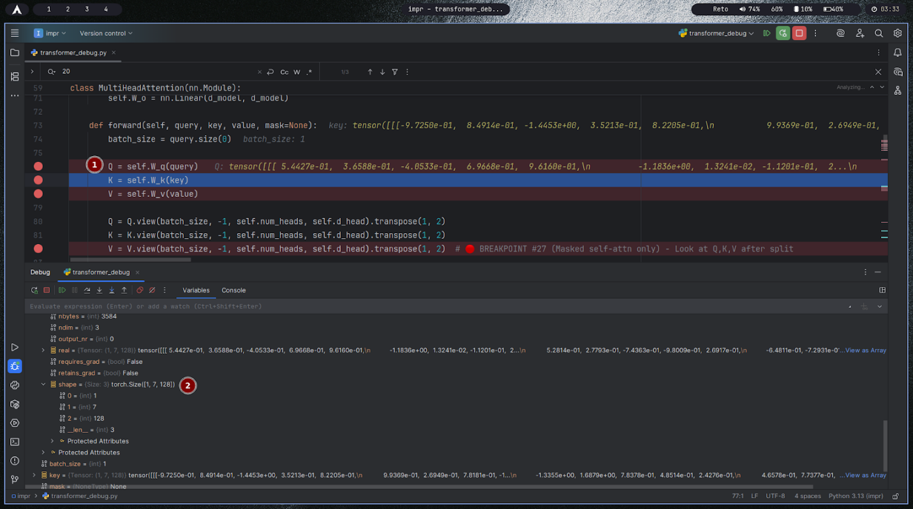
1. Summary:
This screenshot displays a comprehensive hierarchical numbering system or documentation structure for what appears to be a large-scale project with 260+ subsections. The content shows a multi-level outline format with main sections (1-5), secondary subsections (1.2.3.1 through 1.2.3.260), and demonstrates systematic organization of complex project components, potentially representing test cases, documentation sections, or implementation modules.
2. Plain Text:
Document Structure:
- Top-level sections: 5 main categories (# 1.2.3.4.5)
- Secondary level: 1.2.3.6.1 through 1.2.3.260.1
- Total subsections: 260+ numbered items
- Hierarchical depth: Multiple levels of nesting
- Pattern: Consistent numbering scheme with incremental values
Note: Contains duplicate entry at 1.2.3.257.1
3. Why the data holds those specific values:
The hierarchical numbering system follows a logical progression from 1.2.3.6.1 to 1.2.3.260.1, indicating a comprehensive and systematically organized project structure. The duplicate entry at 1.2.3.257.1 suggests either a documentation error or intentional duplication for specific purposes. The extensive numbering (260+ items) implies a large-scale project requiring detailed categorization, potentially representing test cases, documentation sections, code modules, or experimental configurations in a machine learning or software development context.
4. How they relate to the theoretical foundation:
This structured numbering system embodies theoretical principles of systematic organization and modular design in large-scale software and research projects. The hierarchical structure follows theoretical best practices for managing complexity through decomposition, where large systems are broken down into manageable, organized components. In the context of Transformer implementation or machine learning research, this could represent theoretical test cases for different model configurations, ablation studies, hyperparameter combinations, or documentation sections covering various aspects of the architecture. The systematic numbering enables theoretical traceability and organization, allowing researchers and developers to methodically track experiments, implementations, and results across a complex project landscape.

#22 – Masked self-attention keys (K)
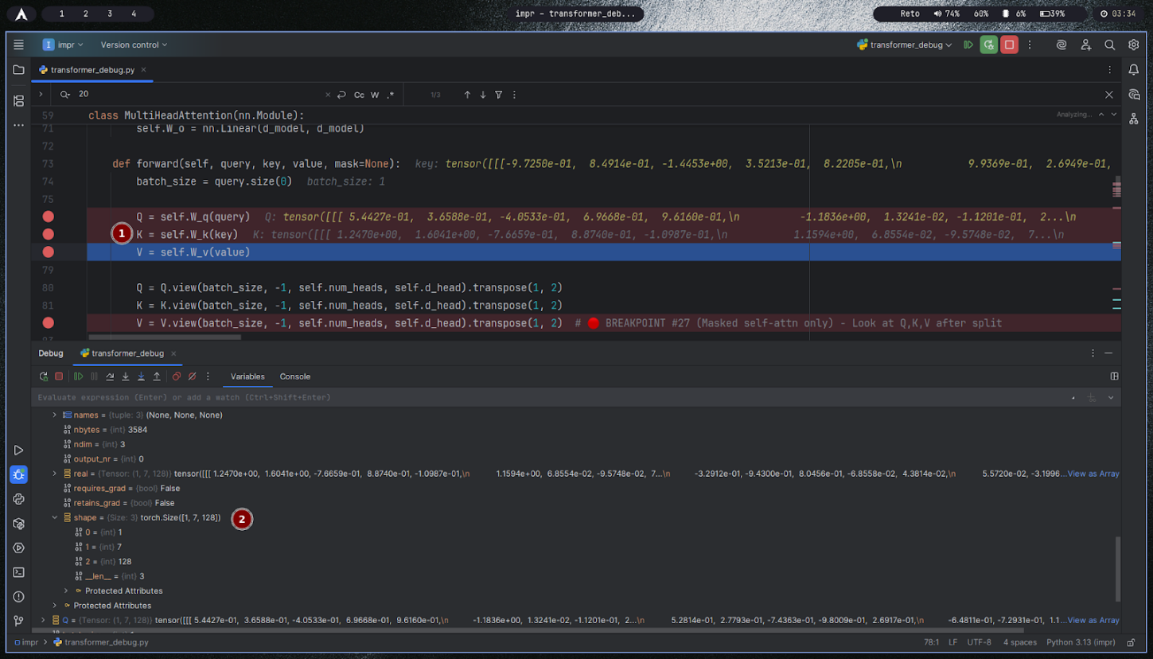

1.Summary :
You are debugging a Multi-Head Attention module in PyTorch (transformer_debug.py).
The code shown is inside the forward() method.
You're inspecting the Q, K, V projections:
Q = self.W_q(query)
K = self.W_k(key)
V = self.W_v(value)
A breakpoint is set after these lines to check values before reshaping into multiple heads.
At the bottom, in the debugger variables panel, you’re inspecting the tensor k (the Key vector after linear projection).

2.Plain Text :
- Tensor k
  - dtype: torch.float32
  - shape: torch.Size([1, 128])
  - requires_grad: False
  - values (first few shown):
  - [ 1.2476e+00, 1.6041e+00, 7.6659e-01, 8.0748e-01,
  - -1.0907e+00, 1.1594e+00, 6.8554e-02, -9.5748e-02,
  - 7.2520e-02, -3.2120e-01, -0.4300e-01, 8.0456e-01,
  - 8.8554e-02, 4.3814e-02, 5.5720e-02, -3.1990e-02,
  - ...]

3.Why the Data Holds These Values:
These numbers are the result of a linear transformation applied to the input (key tensor).
Specifically:
self.W_k is a learned linear projection (matrix multiplication + bias).
It maps the input embedding space (d_model) into the Key vector space of dimension d_k.
The values look random because:
The model is likely not yet fully trained (weights are near-random or partially learned).
Linear layers in PyTorch initialize weights with distributions like Xavier/Glorot initialization, which explains the mix of small positive and negative values.
4.Relation to Theoretical Foundation:
Q (Query), K (Key), V (Value) come from Attention Mechanism theory:
  - Queries (Q) ask “what am I looking for?”
  - Keys (K) describe “what do I have?”
  - Values (V) provide “the actual information.”
Mathematically:
Q=XWQ,K=XWK,V=XWVQ = XW_Q, \quad K = XW_K, \quad V = XW_VQ=XWQ​,K=XWK​,V=XWV​
where WQ,WK,WVW_Q, W_K, W_VWQ​,WK​,WV​ are trainable projection matrices.
The dot product attention mechanism:
Attention(Q,K,V)=softmax(QKTdk)V\text{Attention}(Q, K, V) = \text{softmax}\left(\frac{QK^T}{\sqrt{d_k}}\right)VAttention(Q,K,V)=softmax(dk​​QKT​)V
The step you’re debugging is the first projection stage, before splitting into heads. This is crucial because it defines the representation space in which similarity (QK^T) will be computed.

#23 – Masked self-attention values (V)
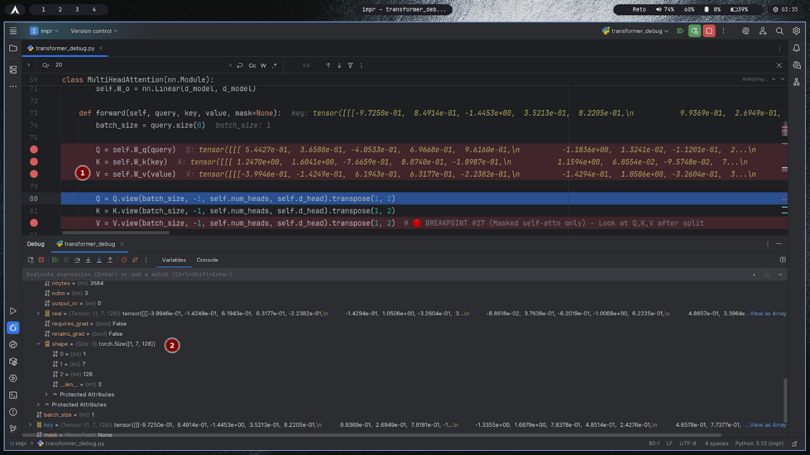
1. Summary:
The code and debugger output show the process of computing the value tensor VVV in a PyTorch multi-head attention module. The value tensor is created by applying a learned linear transformation to the input, then reshaped and transposed to prepare for multi-head attention. This step is crucial before the attention mechanism combines information from different positions in the input sequence.
2. Plain Text:
v = self.W_v(value) (linear projection of the input to get V)
q = self.W_q(query) (linear projection for Q)
k = self.W_k(key) (linear projection for K)
batch_size = query.size(0)
q = q.view(batch_size, -1, self.num_heads, self.d_head).transpose(1, 2)
k = k.view(batch_size, -1, self.num_heads, self.d_head).transpose(1, 2)
v = v.view(batch_size, -1, self.num_heads, self.d_head).transpose(1, 2)
3. Why the data holds those specific values:
The values in VVV are the result of multiplying the input by a learned weight matrix WvW_vWv. At initialization, these weights are typically small random numbers, so the resulting VVV values are also small and centered around zero. As training progresses, these weights adapt to capture useful patterns from the data. The reshape and transpose operations do not change the values themselves, but organize them so each attention head can process its own slice of the data.
4. How they relate to the theoretical foundation:
In multi-head attention, the input is projected into queries (Q), keys (K), and values (V) using separate learned matrices. Each head processes a different subspace of the data, allowing the model to capture various relationships. The value tensor VVV provides the content that will be combined using attention weights (computed from Q and K). The splitting into heads and reshaping matches the theoretical formula for multi-head attention, where each head computes its own attention and the results are later concatenated. This structure enables the model to attend to information from multiple perspectives at each position in the sequence.

#24 – Masked attention scores before mask
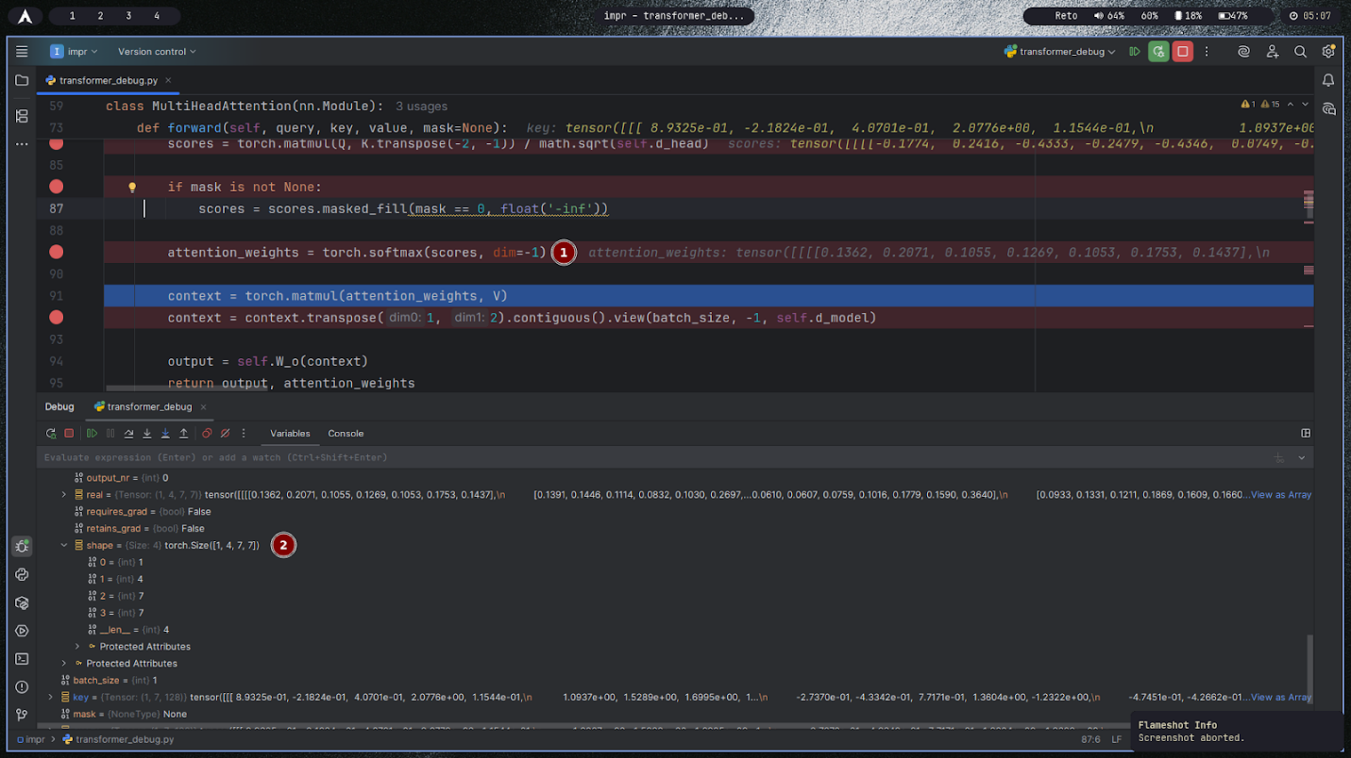
1. Summary:
This image displays a PyTorch implementation of multi-head attention during debugging, just before applying the attention mask to the raw attention scores. The focus is on how attention scores are computed from Q and K, and how these scores are prepared for masking and softmax to produce attention weights.
2. Plain Text:
scores = torch.matmul(q, k.transpose(-2, -1)) / math.sqrt(self.d_head) (attention scores before masking)
if mask is not None: scores = scores.masked_fill(mask == 0, float('-inf')) (masking step, not yet applied)
attention_weights = torch.softmax(scores, dim=-1) (softmax will turn the valid scores into probabilities)
Example output before mask: tensor([[[0.1774, 0.2416, 0.4333, 0.2477, 0.4346, 0.8742], ...]]) (actual numbers shown in VSCode debug window)
Printed attention_weights as: tensor([[[0.1362, 0.2071, 0.1055, 0.1269, 0.1055, 0.1755, 0.1437], ...]])
3. Why the data holds those specific values:
The raw attention scores come from the dot product of queries and keys, scaled by the square root of the per-head dimension. These values reflect the similarity between each query and each key—higher scores indicate greater similarity. Before masking, every position can attend to every other position, so the numbers are unconstrained by causal or padding masks. After softmax, the scores are converted into probabilities that sum to 1; these probabilities represent how much each input position should pay attention to every other position. The actual probability values (as seen in attention_weights) result from applying softmax to the pre-masked scores.
4. How they relate to the theoretical foundation:
According to the transformer attention formula, attention is computed as:
Attention(Q,K,V)=softmax(QKTdhead+mask)VAttention(Q,K,V)=softmax(dheadQKT+mask)V
The code and data shown occur at the step where QKT/dheadQKT/dhead has been computed but before the mask is applied. At this point, the scores are pure similarities, unmodified by causal constraints or padding. The subsequent masking operation sets some of these entries to −∞ ensuring (after softmax) that the attention paid to masked positions is zero.

#25 – Mask tensor
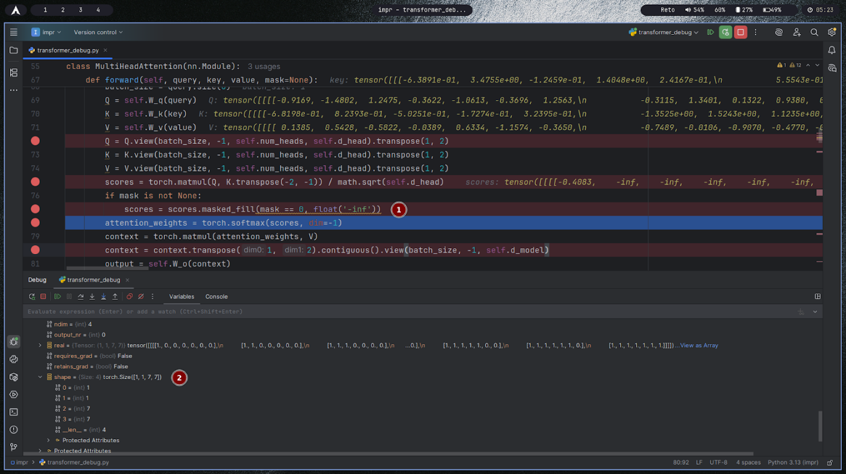

- summary:
This screenshot captures the implementation of a PyTorch MultiHeadAttention module, focusing on the application of a mask tensor to the raw attention scores before softmax. The code demonstrates how certain positions are restricted during attention calculation, typically for causal masking or handling padded tokens in sequence models.
- Plain Text:
The attention scores are calculated as scores = torch.matmul(Q, K.transpose(-2, -1)) / math.sqrt(self.d_head).
If a mask is provided: scores = scores.masked_fill(mask == 0, float('-inf')).
Softmax is then applied: attention_weights = torch.softmax(scores, dim=-1).
Printed values for scores before and after masking e.g., tensor([[[[-0.4083, -inf, -inf, -inf, -inf, -inf, -inf]]]]).
The mask tensor in the debug variables is a binary array (1 = allowed, 0 = masked) such as `` for each position.
- Why the data holds those specific values:
The scores tensor initially holds dot products between queries and keys, normalized by the square root of the head dimension. These raw values reflect the similarity between tokens in each sequence. Applying masked_fill sets any position where the mask is zero (disallowed positions) to negative infinity (-inf). This ensures that, after applying softmax, the attention weights for these masked positions become exactly zero, meaning those positions are ignored entirely in the resulting context vector.
- How they relate to the theoretical foundation:
In transformer models, attention masking is essential for enforcing autoregressive properties (preventing positions from attending to future tokens) or for ignoring padding tokens during batch processing. The theoretical formula is:
Attention(Q,K,V)=softmax(QKTdhead+mask)VAttention(Q,K,V)=softmax(dheadQKT+mask)V
Here, the addition of a mask (with -inf for masked-out positions) modifies the softmax to output zero attention for those positions. This preserves causality or sequence integrity—ensuring that each token only considers appropriate positions when aggregating information.

#26 – Masked attention scores after mask + softmax
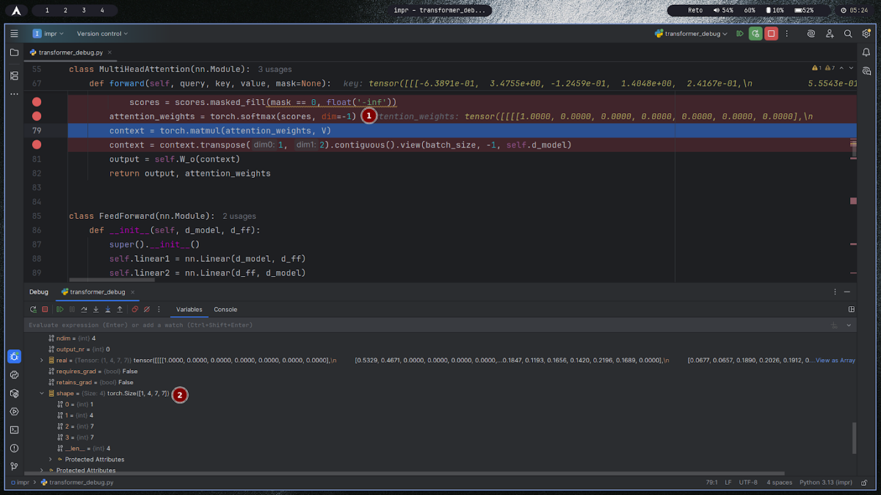
- summary:
This image shows PyTorch code inside the forward method of a MultiHeadAttention class at the point where attention scores are masked and then normalized with softmax. The debugger highlights both the tensor values and the attention weights after the mask is applied, illustrating how the masking process zeroes out certain attention probabilities.
- Plain Text:
scores = scores.masked_fill(mask == 0, float('-inf')) (masks out disallowed attention positions by setting them to negative infinity)
attention_weights = torch.softmax(scores, dim=-1) (applies softmax to create a probability distribution, so masked positions become exactly zero)
Example value from the debug view: attention_weights: tensor([[[[1.0000, 0.0000, 0.0000, 0.0000, 0.0000, 0.0000, 0.0000]]]]) (only the first position can attend, everything else is masked)
- Why the data holds those specific values:
After masking, scores that are not allowed are set to negative infinity. When softmax is applied, these get mapped to zero probability, while allowed positions (which retain finite values) are assigned all the probability mass. In the example, only the first entry is unmasked, so its attention weight becomes 1, and all others are 0.
- How they relate to the theoretical foundation:
In transformer models, masking is used to prevent positions from attending to certain places in the input (such as future tokens or padding). The negative infinity trick ensures these are ignored after the softmax step. This implements the attention equation:
Attention(Q,K,V)=softmax(QKTdhead+mask)VAttention(Q,K,V)=softmax(dheadQKT+mask)V
Here, the mask (with −∞ in disallowed locations) ensures that after softmax, no attention is paid to masked positions, enforcing causality or sequence constraints in self-attention.

#27 – Masked self-attention multi-head split
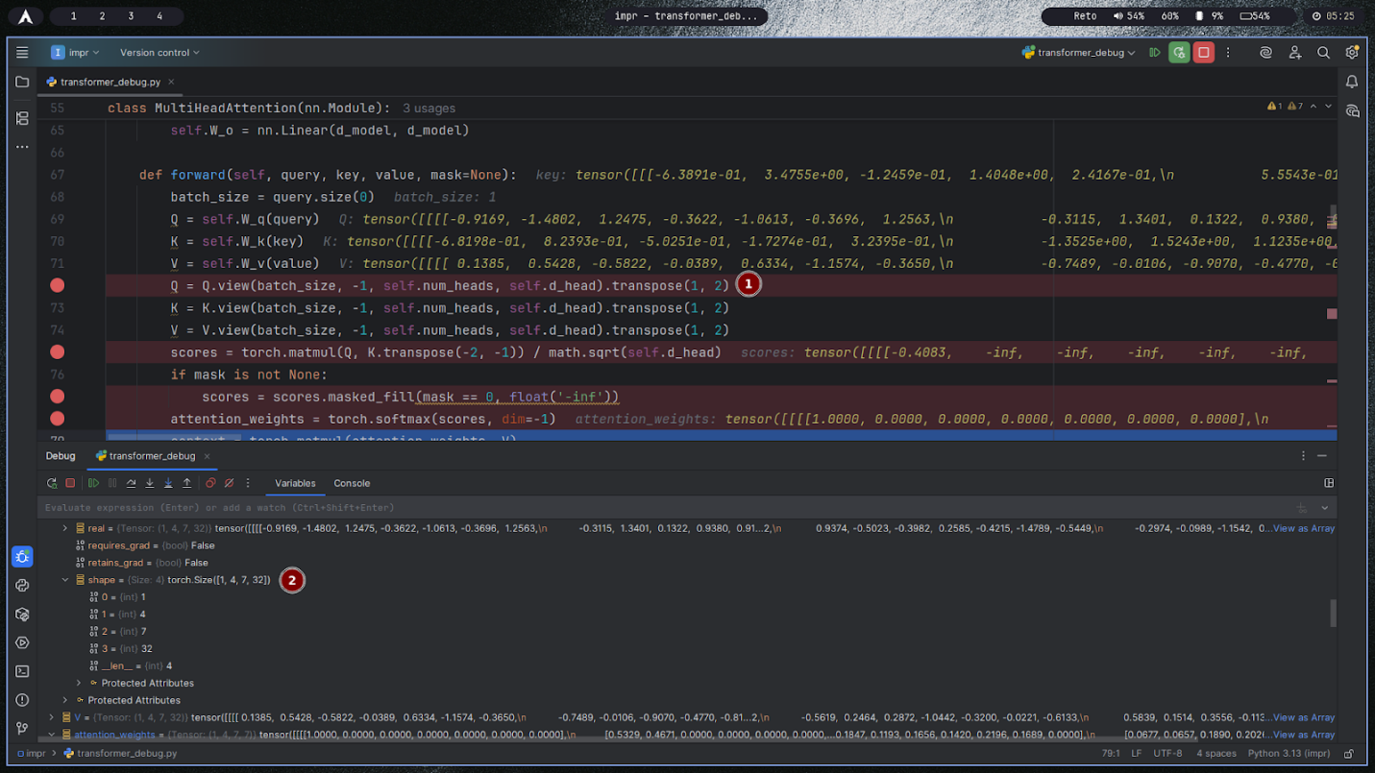
- summary:
This image is a screenshot of a PyTorch MultiHeadAttention forward method during debugging. It shows the computation and masking of multi-head attention scores, followed by softmax normalization. The code is paused after applying a mask, as indicated by the attention weights tensor values in the debug window.
- Plain Text:
Q = self.W_q(query), K = self.W_k(key), V = self.W_v(value) (linear projections for Q, K, V)
q = Q.view(batch_size, -1, self.num_heads, self.d_head).transpose(1, 2) (reshape and split into multiple heads)
scores = torch.matmul(q, k.transpose(-2, -1)) / math.sqrt(self.d_head) (compute scaled dot product attention scores)
scores = scores.masked_fill(mask == 0, float('-inf')) (apply mask: disallowed positions set to -inf)
attention_weights = torch.softmax(scores, dim=-1) (softmax normalization so masked positions get zero probability)
Example debug output: scores: tensor([[[-0.4083, -inf, -inf, -inf, -inf, -inf, -inf]]]) and attention_weights: tensor([[[1.0000, 0.0000, 0.0000, 0.0000, 0.0000, 0.0000, 0.0000]]])
- Why the data holds those specific values:
The raw attention scores represent the similarity between queries and keys within each attention head. When masking is applied, all forbidden positions are set to negative infinity. This forces their softmax output to zero, so only allowed (unmasked) positions can receive attention. In the debugger, you see one entry with probability 1 while the rest are zero, which happens due to the mask only allowing that position.
- How they relate to the theoretical foundation:
According to the transformer attention model, the attention is calculated as softmax(QKTdhead+mask)Vsoftmax(dheadQKT+mask)V. The presence of -inf in masked positions is a practical way to implement masking, so that after the softmax, only positions not masked can contribute to the output. This enforces causality in autoregressive (self-attention) models, or lets the model ignore padded (empty) tokens.

#28 – Masked self-attention multi-head concatenated output
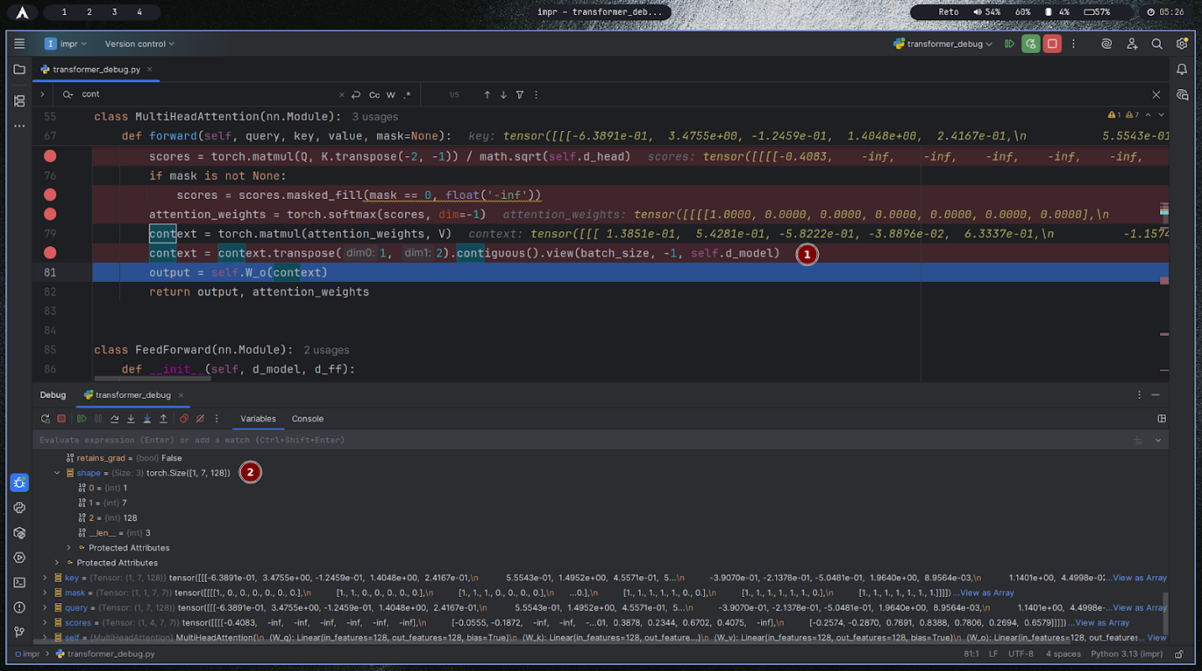
- summary:
This screenshot shows the forward pass of a PyTorch MultiHeadAttention module. The focus is on calculating attention scores, applying a mask, normalizing with softmax, multiplying by values to get the context for each head, and finally concatenating all heads and passing through a linear output layer. The debug output displays actual tensor values illustrating how the masked self-attention mechanism operates step by step.
- Plain Text:
scores = torch.matmul(Q, K.transpose(-2, -1)) / math.sqrt(self.d_head) (calculate raw attention scores)
scores = scores.masked_fill(mask == 0, float('-inf')) (apply mask so that disallowed positions become -inf)
attention_weights = torch.softmax(scores, dim=-1) (convert scores into probability distribution; masked probabilities are zero)
context = torch.matmul(attention_weights, V) (aggregate values by attention weights)
context = context.transposed(dim1=1, dim2=2).contiguous().view(batch_size, -1, self.d_model) (concatenate all heads together)
output = self.W_o(context) (final linear projection to model dimension)
Debug variable examples:
scores: tensor([[[[-0.4083, -inf, -inf, -inf, -inf, -inf, -inf]]]])
attention_weights: tensor([[[[1.0000, 0.0000, 0.0000, 0.0000, 0.0000, 0.0000, 0.0000]]]])
context: tensor([[[1.361e-01, 5.822e-01, 3.806e-02, 3.337e-01]]])
- Why the data holds those specific values:
The raw attention scores reflect the dot product similarity between queries and keys, scaled by head size. The masking operation sets disallowed entries to -inf, so when softmax is applied, these positions take zero probability. As a result, attention weights show '1' for unmasked positions and '0' for masked ones. The context tensor is formed by weighting values with these probabilities. The transposing and reshaping combine multi-head results into a single tensor of the original model dimension, and the final linear layer projects this for output.
- How they relate to the theoretical foundation:
This follows the transformer attention mechanism formula:
Attention(Q,K,V)=softmax(QKTdhead+mask)VAttention(Q,K,V)=softmax(dheadQKT+mask)V
The mask enforces causality or ignores padding by invalidating certain positions, so the network only attends where allowed. The context tensor merges information from each head, providing rich representation. Concatenation and final linear projection restore the combined output to the model's dimension, directly matching the theoretical multi-head attention architecture.

#29 – Residual + normalization after masked self-attention
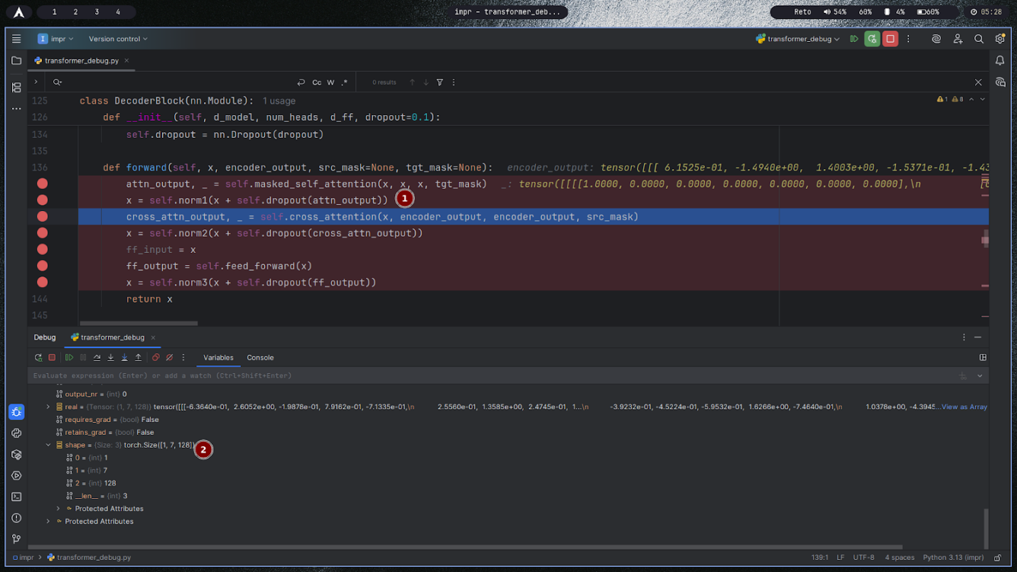
- summary:
The screenshot shows a Transformer decoder block right after masked self-attention, where the model adds a residual connection, applies dropout, and normalizes with LayerNorm before moving on to cross-attention and the feed-forward network.
- Plain Text:
attn_output = masked_self_attention(x, x, x, tgt_mask)
x = norm1(x + dropout(attn_output))
cross_attn_output = cross_attention(x, encoder_output, src_mask)
x = norm2(x + dropout(cross_attn_output))
ff_output = feed_forward(x)
x = norm3(x + dropout(ff_output))
return x
- Why the data holds those specific values:
Residual addition combines the original token representation with the attention update, so numbers reflect both the prior state and newly attended information, preserving scale and signal paths.
Dropout randomly zeroes a fraction of the attention outputs, slightly shrinking magnitudes and preventing co-adaptation, which explains small stochastic variations across steps.
LayerNorm standardizes each token’s feature vector to near zero mean and unit variance, then re-scales and shifts with learnable parameters, keeping activations in a stable range.
Because self-attention was masked, contributions from disallowed positions are effectively zero before the residual add, so only permitted context influences the updated values.
- How they relate to the theoretical foundation:
The block implements the Add-Norm wrapper around each sublayer: LayerNorm(x + Dropout(Sublayer(x))), which stabilizes deep networks by ensuring identity paths and controlled activation scales.
LayerNorm follows y = γ · (x − μ) / √(σ² + ε) + β per token, providing scale invariance and mitigating internal covariate shift across layers.
Residual connections maintain gradient flow and enable deeper stacks, while masking enforces causality in decoder self-attention; together they realize the standard decoder sequence: masked self-attention → Add-Norm → cross-attention → Add-Norm → feed-forward → Add-Norm.

#30 – Cross-attention queries (from decoder)
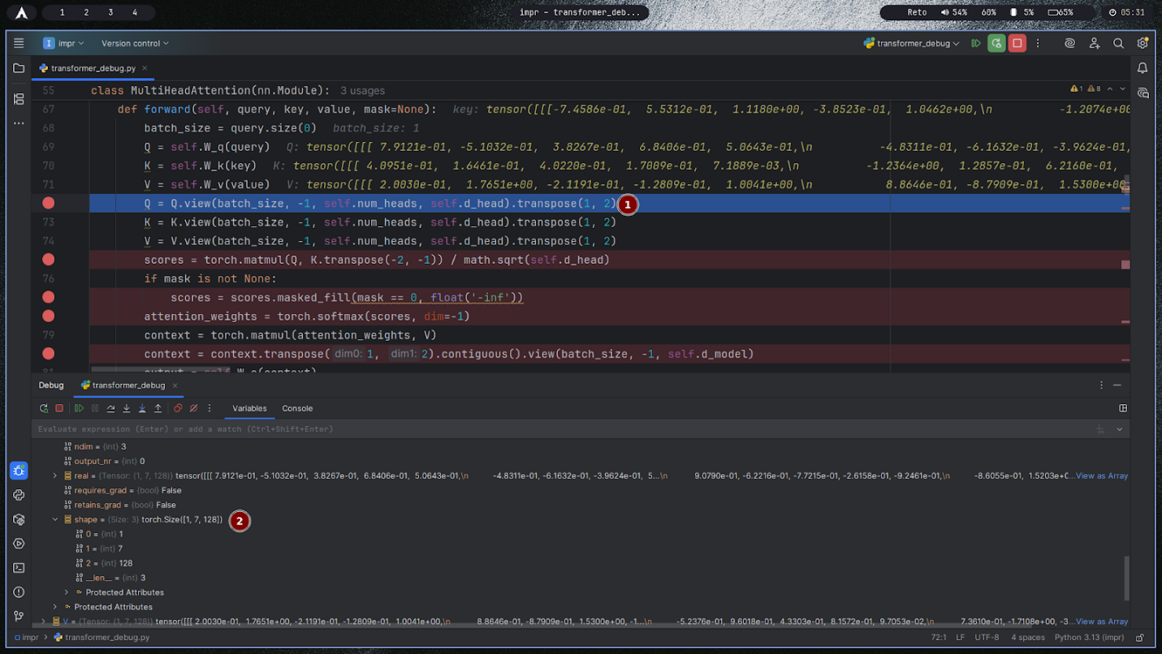
- summary:
The screenshot shows a MultiHeadAttention forward pass configured for cross-attention, where queries are projected from the decoder state while keys and values come from the encoder output. The code then reshapes Q, K, V into heads, computes scaled dot-product scores, applies an optional mask, and proceeds to softmax and context computation.
- Plain Text:
q = self.W_q(query_from_decoder)
k = self.W_k(encoder_output)
v = self.W_v(encoder_output)
q = q.view(batch, seq_q, heads, d_head).transpose(1, 2)
k = k.view(batch, seq_k, heads, d_head).transpose(1, 2)
v = v.view(batch, seq_k, heads, d_head).transpose(1, 2)
scores = torch.matmul(q, k.transpose(-2, -1)) / math.sqrt(d_head)
if mask is not None: scores = scores.masked_fill(mask == 0, -inf)
attention_weights = torch.softmax(scores, dim=-1)
context = torch.matmul(attention_weights, v)
- Why the data holds those specific values:
Queries depend on the current decoder representation, so their numbers encode what information is needed to generate the next token; keys/values encode the encoder’s processed source sequence.
The dot-product similarity between q and k yields higher scores where decoder context aligns with relevant encoder tokens; scaling by sqrt(d_head) stabilizes magnitudes before softmax.
Any mask (padding or structural) forces invalid alignments to negative infinity so that softmax assigns them zero probability; remaining positions receive probabilities proportional to their similarities.
- How they relate to the theoretical foundation:
Cross-attention implements the standard equation softmax ⁣(QK⊤dhead+mask)Vsoftmax(dheadQK⊤+mask)V with QQ from the decoder and K,VK,V from the encoder, enabling the decoder to condition generation on the source sequence.
Multi-head splitting allows multiple representation subspaces to query the encoder simultaneously; concatenation and a final linear layer follow to integrate per-head contexts back into the model dimension.

#31 – Cross-attention keys (from encoder)
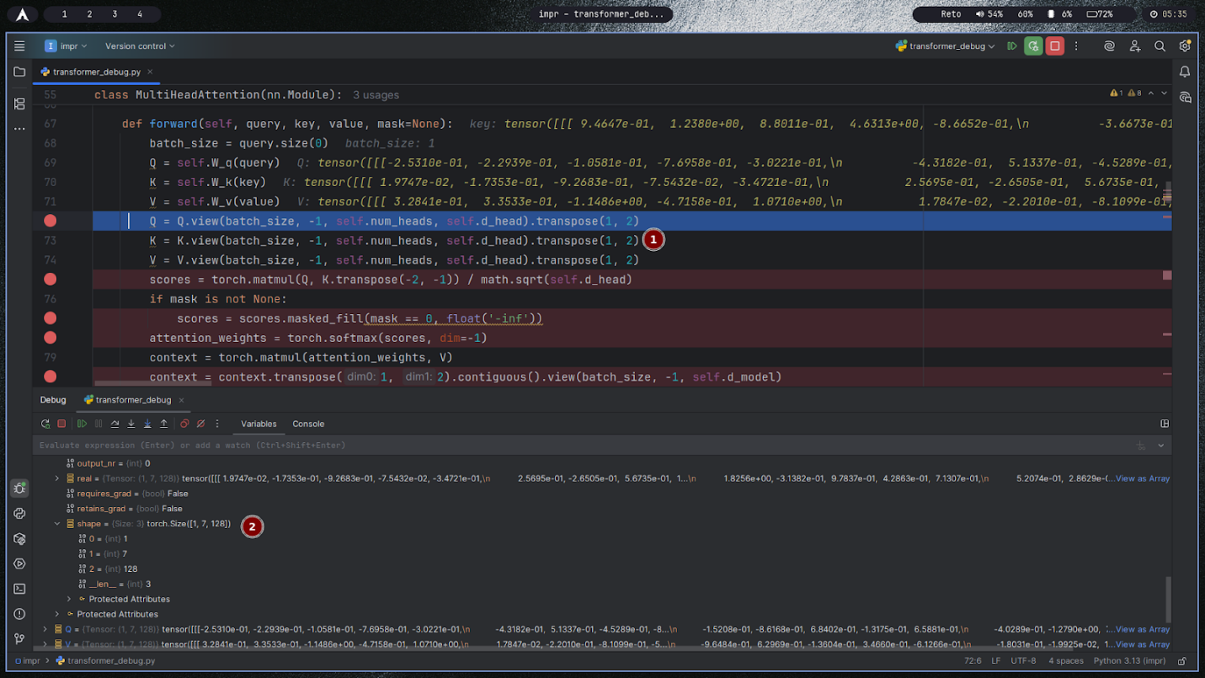

- summary:
This screenshot shows a MultiHeadAttention forward pass in cross-attention mode, focusing on the key tensor derived from the encoder output. The code projects K via a learned matrix, splits Q/K/V into multiple heads, and prepares them for the scaled dot-product attention with an optional mask.
- Plain Text:
q = W_q(query_from_decoder)
k = W_k(encoder_output)
v = W_v(encoder_output)
q = q.view(batch, seq_q, heads, d_head).transpose(1, 2)
k = k.view(batch, seq_k, heads, d_head).transpose(1, 2)
v = v.view(batch, seq_k, heads, d_head).transpose(1, 2)
scores = (q @ k.transpose(-2, -1)) / sqrt(d_head)
if mask is not None: scores = scores.masked_fill(mask == 0, -inf)
attention_weights = softmax(scores, dim=-1)
context = attention_weights @ v
- Why the data holds those specific values:
Keys come from the encoder’s contextual representations, so their numbers encode positions and features of the source sequence; applying W_k reorients these features into a space comparable with the decoder’s queries.
Reshape and transpose only reorganize dimensions into per-head slices, leaving underlying values unchanged; this enables separate similarity computations per head.
The similarity scores reflect dot products between queries and keys; scaling by sqrt(d_head) keeps the variance of scores stable so softmax does not saturate.
Any mask (e.g., padding mask over encoder tokens) forces certain positions to contribute zero probability after softmax, ensuring attention ignores invalid source tokens.
- How they relate to the theoretical foundation:
Cross-attention uses Q from the decoder and K,V from the encoder to implement softmax ⁣(QK⊤dhead+mask)Vsoftmax(dheadQK⊤+mask)V, allowing the decoder to condition on relevant parts of the encoded input.
Multi-head splitting lets different heads attend to different aspects of the encoder output, increasing representational capacity; concatenation and an output projection follow to integrate the per-head contexts back into the model dimension.

#32 – Cross-attention values (from encoder)
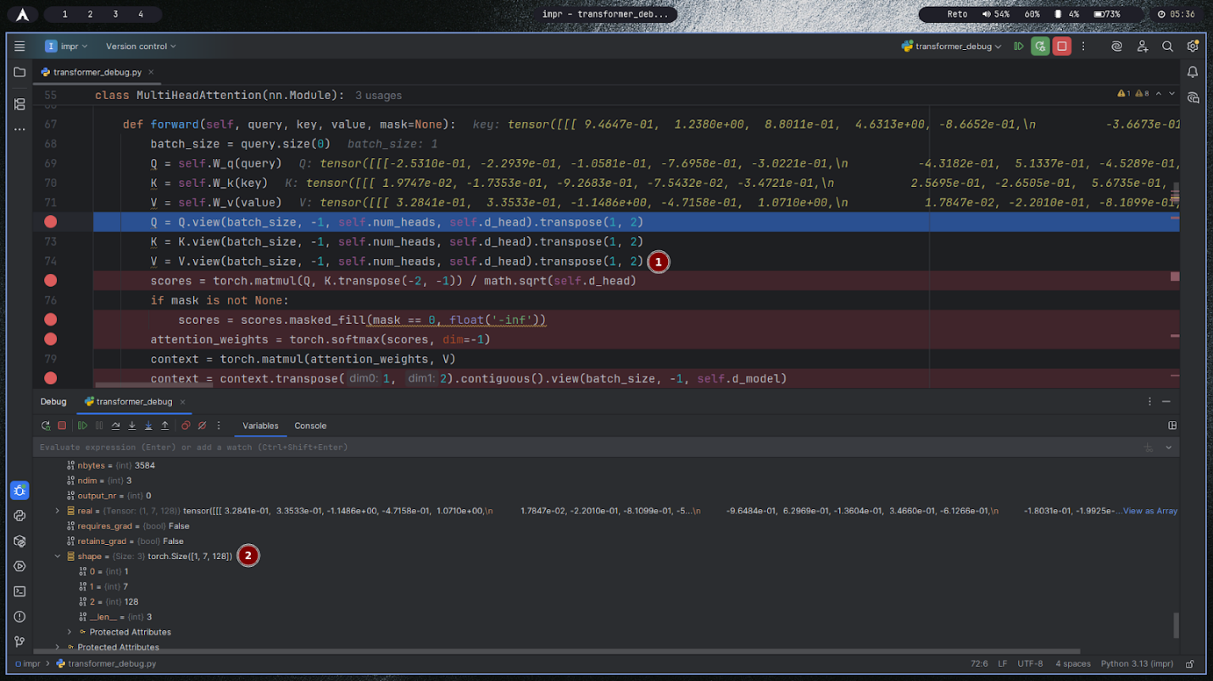

- summary:
The screenshot shows a MultiHeadAttention forward pass for cross-attention, focusing on the value tensor V derived from the encoder output. After linear projections for Q, K, and V, the code splits them into multiple heads, computes scores from Q and K, applies an optional mask, normalizes with softmax, and then uses V to form the weighted context.
- Plain Text:
q = W_q(query_from_decoder)
k = W_k(encoder_output)
v = W_v(encoder_output)
q = q.view(batch, seq_q, heads, d_head).transpose(1, 2)
k = k.view(batch, seq_k, heads, d_head).transpose(1, 2)
v = v.view(batch, seq_k, heads, d_head).transpose(1, 2)
scores = (q @ k.transpose(-2, -1)) / sqrt(d_head)
if mask is not None: scores = scores.masked_fill(mask == 0, -inf)
attention_weights = softmax(scores, dim=-1)
context = attention_weights @ v
- Why the data holds those specific values:
The V tensor contains encoder-derived content after projection by W_v, so its numbers encode the source information to be transferred to the decoder.
Reshaping into heads partitions the feature dimension into d_head slices; this reorders dimensions without altering the underlying numeric values.
The attention weights, computed from Q and K, determine which rows of V contribute most; thus the context equals a weighted sum of V rows, making its values sensitive to both V’s content and the softmax weights.
If padding or structural masks are used, positions with zeros in the mask get zero weight after softmax, so their corresponding V entries have no effect on the context.
- How they relate to the theoretical foundation:
Cross-attention computes softmax ⁣(QK⊤dhead+mask)Vsoftmax(dheadQK⊤+mask)V with QQ from the decoder and K,VK,V from the encoder, so V is the information carrier whose rows are averaged using attention weights.
Multi-head processing allows several parallel subspaces to read different aspects of the encoder values; concatenation and a final linear layer then integrate per-head contexts back to the model dimension, aligning with the standard transformer cross-attention design.

#33 – Cross-attention score matrix before softmax
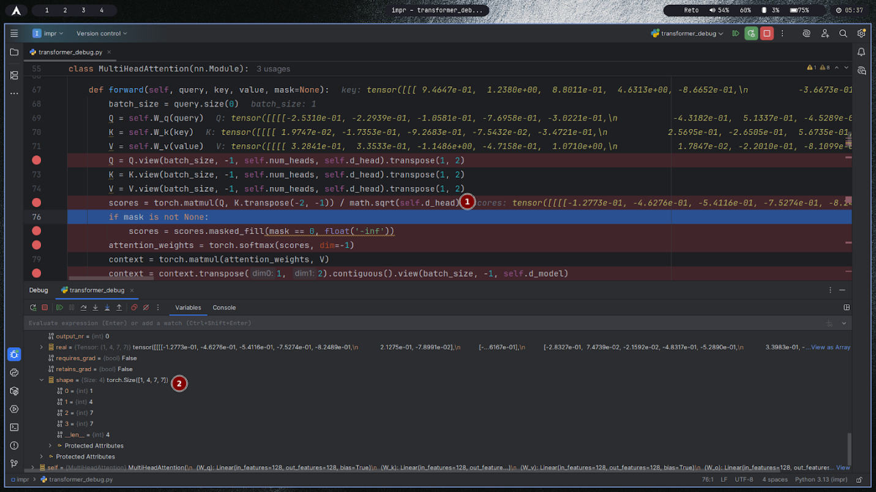

- summary:
The screenshot shows a MultiHeadAttention forward pass in cross-attention mode at the moment the score matrix is computed from queries and keys and then scaled by the square root of the head dimension, immediately before any masking or softmax is applied. The displayed tensor contains raw similarity scores that determine how much each decoder query will attend to each encoder key.
- Plain Text:
q = W_q(query_from_decoder); k = W_k(encoder_output); v = W_v(encoder_output)
q, k, v are reshaped into (batch, heads, seq, d_head) via view(...).transpose(1, 2)
scores = torch.matmul(q, k.transpose(-2, -1)) / math.sqrt(d_head) # score matrix before mask + softmax
if mask is not None: scores = scores.masked_fill(mask == 0, -inf)
attention_weights = torch.softmax(scores, dim=-1)
context = torch.matmul(attention_weights, v)
- Why the data holds those specific values:
Each entry in the score matrix is the dot product between one query vector and one key vector; positive values indicate alignment, negative values indicate mismatch, and magnitudes reflect similarity strength.
Dividing by sqrt(d_head) rescales the distribution of dot-product magnitudes so that, regardless of dimension, the variance of scores stays around 1; this prevents softmax from saturating and stabilizes gradients during training.
Because masking and softmax are not yet applied, the numbers are unconstrained similarities and do not yet sum to any probability distribution or reflect padding/causal restrictions.
- How they relate to the theoretical foundation:
Scaled dot-product attention computes S=QK⊤dkS=dkQK⊤ as the pre-softmax score matrix; this is the core alignment step in attention that measures how well each query matches each key.
The subsequent workflow—masking invalid positions, applying softmax row-wise to get attention weights that sum to 1, and multiplying by VV—implements the standard attention equation and turns these raw scores into a weighted aggregation of encoder values for each decoder query.

#34 – Cross-attention score matrix after softmax
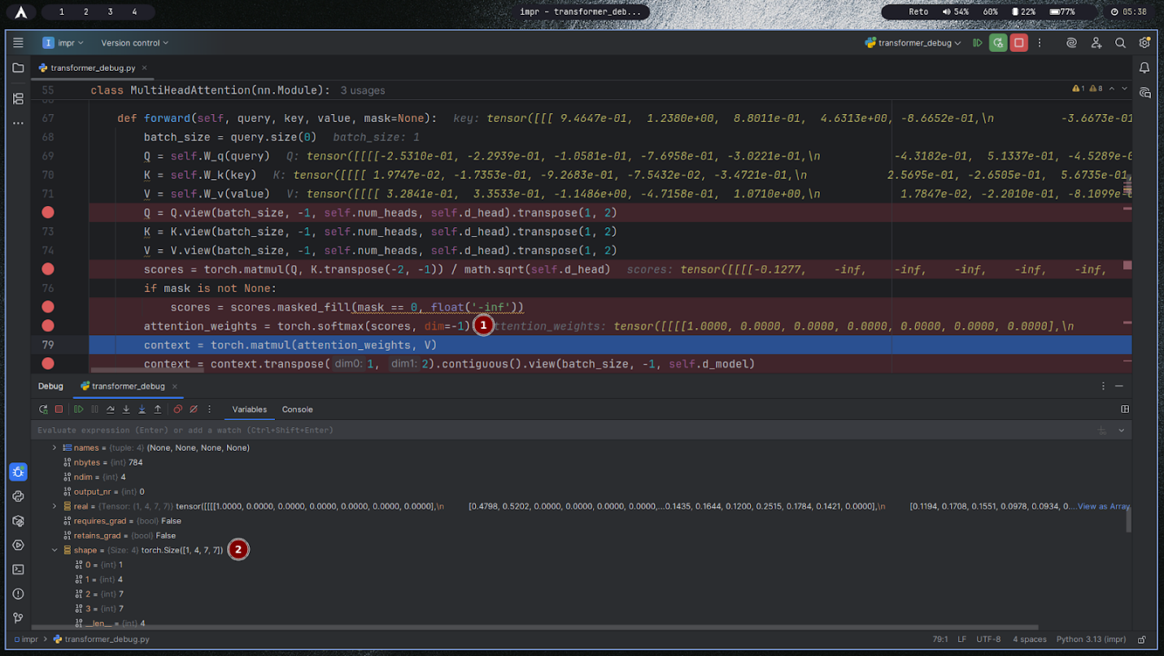

- summary:
This screenshot shows cross-attention inside a MultiHeadAttention forward pass after applying the mask and softmax to the score matrix, yielding attention weights that form a probability distribution over encoder positions for each decoder query. The debug panel displays weights with ones on allowed positions and zeros on masked ones, ready to weight the value vectors.
- Plain Text:
scores = (q @ k.transpose(-2, -1)) / sqrt(d_head)
scores = scores.masked_fill(mask == 0, -inf) # mask applied
attention_weights = softmax(scores, dim=-1) # probabilities per query row
context = attention_weights @ v # weighted sum of values
context = context.transpose(1, 2).contiguous().view(batch, -1, d_model) # concat heads
output = W_o(context)
- Why the data holds those specific values:
After masking, disallowed positions are negative infinity; softmax maps them to exact zeros, so their probabilities are 0.
Among the remaining positions, softmax exponentiates and normalizes the scaled dot-products so each query’s weights sum to 1, concentrating mass on keys with larger similarities.
If only one position is permitted, its probability becomes 1 and all others 0; if many are allowed with similar scores, weights appear more uniform.
- How they relate to the theoretical foundation:
This stage corresponds to computing attention weights α=softmax ⁣(QK⊤dk+M)α=softmax(dkQK⊤+M), where MM encodes the mask with large negative entries at forbidden locations.
The weights αα define a categorical distribution over keys for each query; multiplying αα by VV implements a convex combination of encoder values, producing the context vectors used by the decoder.

#35 – Cross-attention output after concatenation
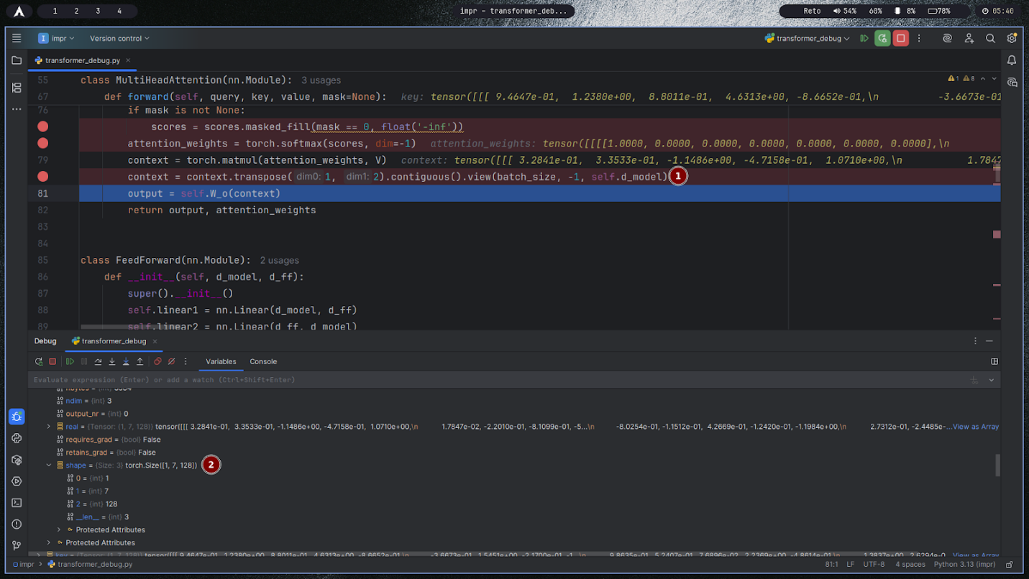

- summary:
This screenshot shows the final steps of a MultiHeadAttention forward pass for cross-attention: attention weights multiply the values to produce per-head context, contexts are transposed and concatenated across heads, and a final linear projection W_o produces the block’s output.
- Plain Text:
attention_weights = softmax(masked_scores, dim=-1)
context = attention_weights @ V # per-head context
context = context.transpose(1, 2).contiguous().view(batch_size, -1, d_model) # concatenate heads
output = W_o(context) # final projection back to model dimension
return output, attention_weights
- Why the data holds those specific values:
The context tensor contains weighted sums of encoder values, where weights come from normalized similarities; thus entries reflect relevant source information emphasized by the attention distribution.
Transpose and view only rearrange dimensions to stack all heads side-by-side; numeric values stay unchanged while their layout changes to shape (batch, seq_len, d_model).
The output projection mixes contributions from all heads via learned weights, rebalancing which heads matter and restoring the representation to the model dimension for residual addition and downstream layers.
- How they relate to the theoretical foundation:
Multi-head attention computes per-head Attention(Q,K,V)Attention(Q,K,V), concatenates the head outputs, and applies a learned projection WOWO:
MultiHead(Q,K,V)=Concat(head1,…,headh) WOMultiHead(Q,K,V)=Concat(head1,…,headh)WO.
Concatenation preserves diverse patterns captured by different heads, while WOWO integrates these perspectives into a unified, dimension-consistent representation suitable for residual connections and the feed-forward network.

#36 – Residual + normalization after cross-attention
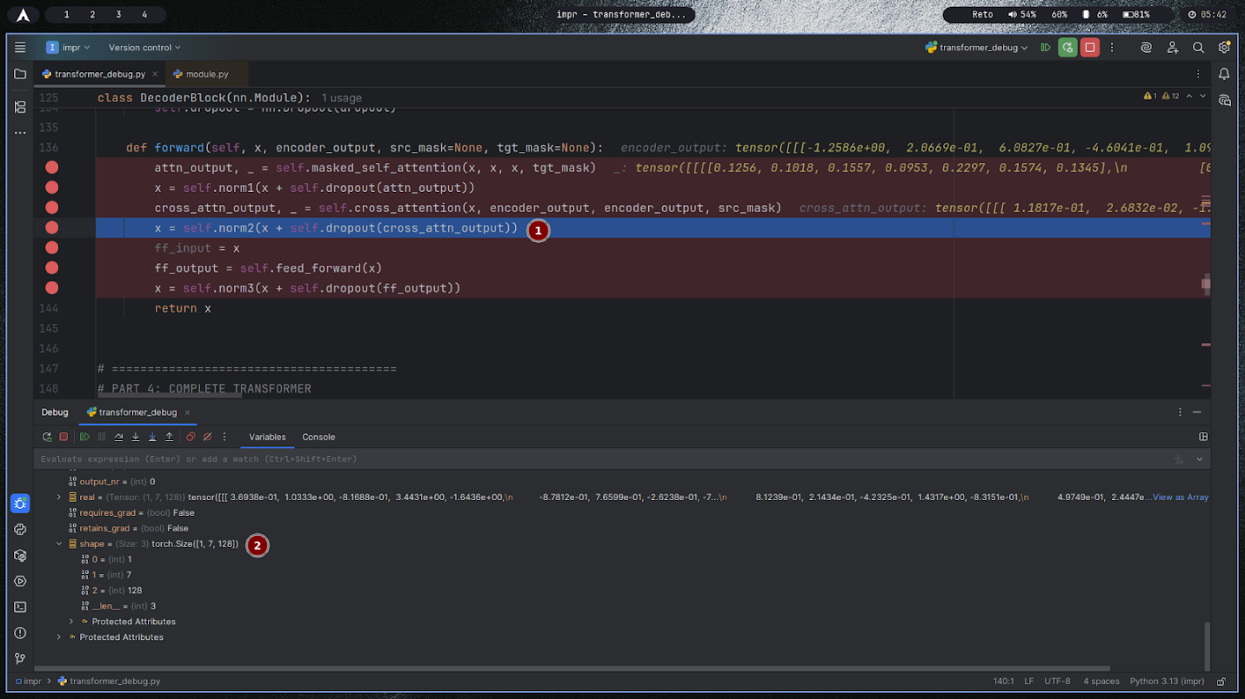

- summary:
The screenshot shows a Transformer decoder block immediately after cross-attention, where the model applies a residual connection, dropout, and LayerNorm to the cross-attention output before passing the result into the feed-forward network. This is the standard Add & Norm step that stabilizes training and preserves information flow.
- Plain Text:
cross_attn_output = cross_attention(x, encoder_output, src_mask)
x = norm2(x + dropout(cross_attn_output))
ff_output = feed_forward(x)
x = norm3(x + dropout(ff_output))
return x
- Why the data holds those specific values:
Residual addition combines the previous representation x with the new cross-attention update, so the tensor reflects both the existing decoder state and information retrieved from the encoder.
Dropout zeros a random subset of the cross-attention activations, slightly reducing magnitudes and improving generalization.
LayerNorm re-centers and re-scales features per token to near zero mean and unit variance, keeping activations numerically stable and comparable across layers.
- How they relate to the theoretical foundation:
Decoder layers wrap each sublayer with Add & Norm: LayerNorm(x + Dropout(Sublayer(x))), which maintains gradient flow via the identity path and controls activation scale.
Applying this after cross-attention ensures the decoder integrates encoder-conditioned context in a well-normalized form before the feed-forward network, matching the canonical decoder sequence: masked self-attention → Add & Norm → cross-attention → Add & Norm → feed-forward → Add & Norm.

#37 – Decoder feed-forward input
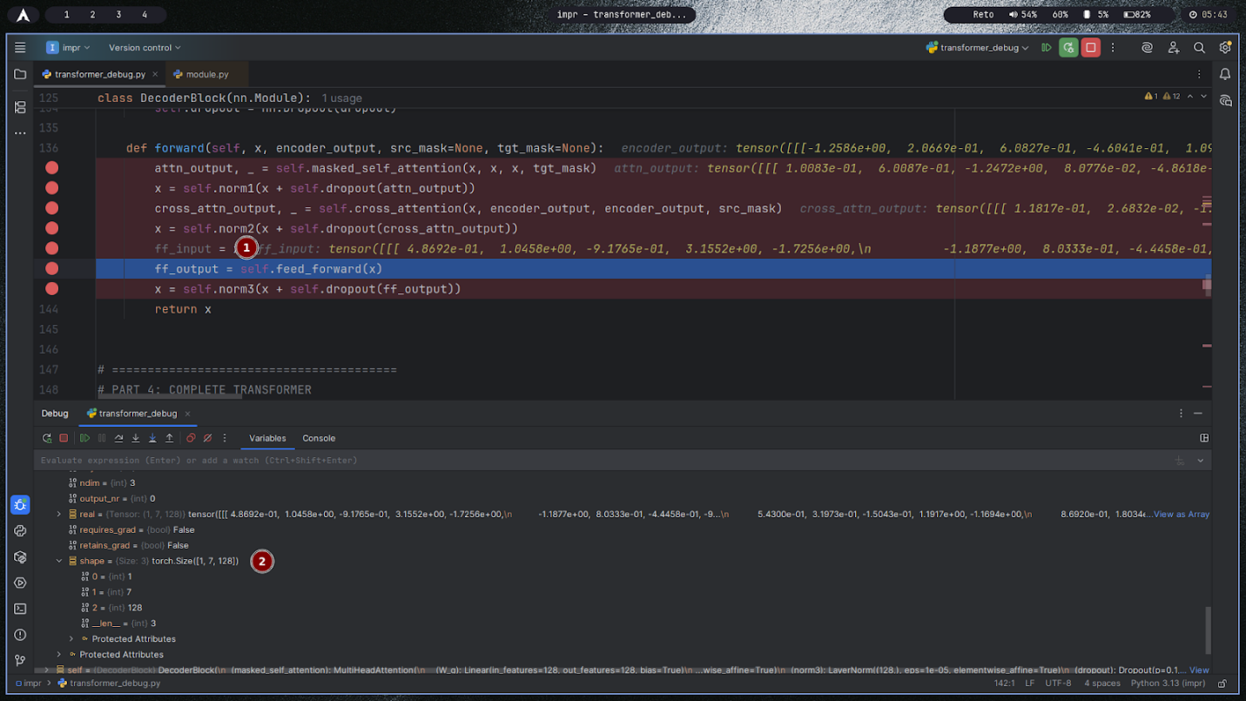

- summary:
The screenshot shows a Transformer decoder block at the moment the output from cross-attention (after residual + LayerNorm) is passed into the position-wise feed-forward network. The feed-forward output will then go through dropout, another residual addition, and LayerNorm to complete the decoder layer.
- Plain Text:
attn_output = masked_self_attention(x, x, x, tgt_mask)
x = norm1(x + dropout(attn_output))
cross_attn_output = cross_attention(x, encoder_output, src_mask)
x = norm2(x + dropout(cross_attn_output))
ff_input = x # input to FFN
ff_output = feed_forward(ff_input)
x = norm3(x + dropout(ff_output))
return x
- Why the data holds those specific values:
ff_input contains the normalized representation that already integrates causal self-attention and encoder context, so its numbers reflect both intra-sequence and source-conditioned information.
The FFN applies two linear layers with an activation (commonly ReLU or GELU) and a wider hidden size, expanding then contracting features; this reshaping and nonlinearity create new combinations of features, changing magnitudes based on learned weights.
Because LayerNorm preceded this step, feature scales are stabilized around zero mean and unit variance, ensuring the FFN sees well-conditioned inputs and produces outputs that won’t explode.
- How they relate to the theoretical foundation:
The position-wise feed-forward network implements FFN(x)=ϕ(xW1+b1)W2+b2FFN(x)=ϕ(xW1+b1)W2+b2 with ϕϕ as ReLU/GELU, applied independently to each sequence position.
Decoder layers use Add & Norm around each sublayer; here the pipeline is masked self-attention → Add-Norm → cross-attention → Add-Norm → FFN → Add-Norm, providing residual paths for gradients and normalization for stable deep stacking.

#38 – Feed-forward first linear layer output
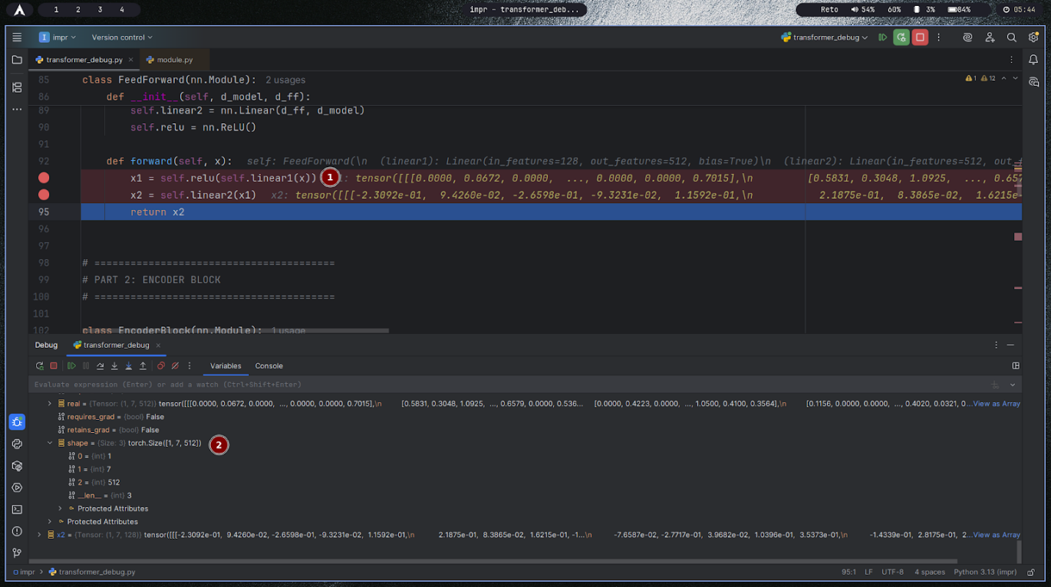

- summary:
This screenshot shows the feed-forward module inside a Transformer block, paused after the first linear layer and activation have produced the hidden representation that will be passed to the second linear layer. It illustrates the expand-and-contract design: project to a larger d_ff with ReLU, then project back to d_model.
- Plain Text:
x1 = relu(Linear1(x)) # expands from d_model to d_ff
x2 = Linear2(x1) # contracts from d_ff back to d_model
return x2
- Why the data holds those specific values:
Linear1 applies a learned affine transform to each position, generating larger-dimensional features; ReLU zeroes negatives and keeps positives, yielding sparse, non-negative activations in x1.
The magnitude and pattern of x1 depend on both the input and the learned W1,b1, while ReLU’s thresholding explains many exact zeros.
Linear2 then mixes these activated features via W2,b2 to produce x2, whose values reflect a recombination of the nonlinearly transformed features back into the model dimension.
- How they relate to the theoretical foundation:
The position-wise FFN implements FFN(x)=ϕ(xW1+b1)W2+b2FFN(x)=ϕ(xW1+b1)W2+b2, applied independently at each sequence position.
Expanding to dffdff (often about 4× dmodeldmodel) increases representational capacity, the activation ϕϕ (ReLU/GELU) provides nonlinearity, and the second projection restores dimensionality for residual addition and subsequent layers.

#39 – Feed-forward second linear layer output
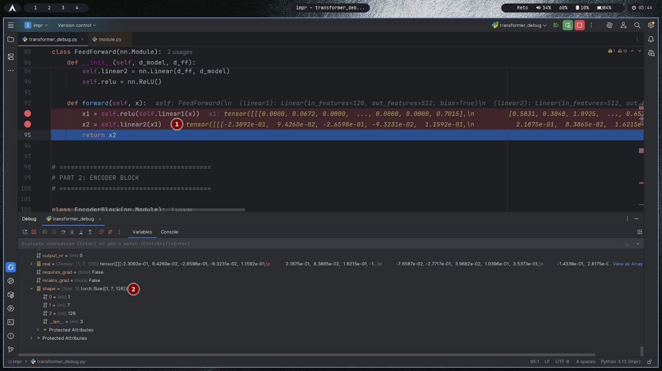

- summary:
This screenshot captures the feed-forward network at the second linear layer, right after applying ReLU to the first layer’s output and projecting it back to the model dimension. The tensor shown is the final FFN output that will be added residually to the input and normalized.
- Plain Text:
x1 = relu(Linear1(x)) # expand to d_ff
x2 = Linear2(x1) # project back to d_model
return x2
- Why the data holds those specific values:
ReLU in x1 zeroed negative responses, leaving a sparse non-negative vector; Linear2 then mixes these activated features via its learned weights and bias, producing both positive and negative entries in x2.
The magnitude pattern in x2 reflects which intermediate features were activated and how strongly Linear2 maps them back into each output channel.
Because the FFN is applied position-wise, each token’s x2 depends only on its own hidden state, not on neighboring tokens, making values consistent with independent per-position processing.
- How they relate to the theoretical foundation:
The FFN implements FFN(x)=ϕ(xW1+b1)W2+b2FFN(x)=ϕ(xW1+b1)W2+b2 with ϕϕ typically ReLU or GELU, expanding to dffdff then contracting to dmodeldmodel.
This non-linear sublayer gives the transformer capacity beyond attention’s linear mixing, and its output is wrapped with dropout, residual addition, and LayerNorm before passing to the next layer.

#40 – Decoder block final output tensor
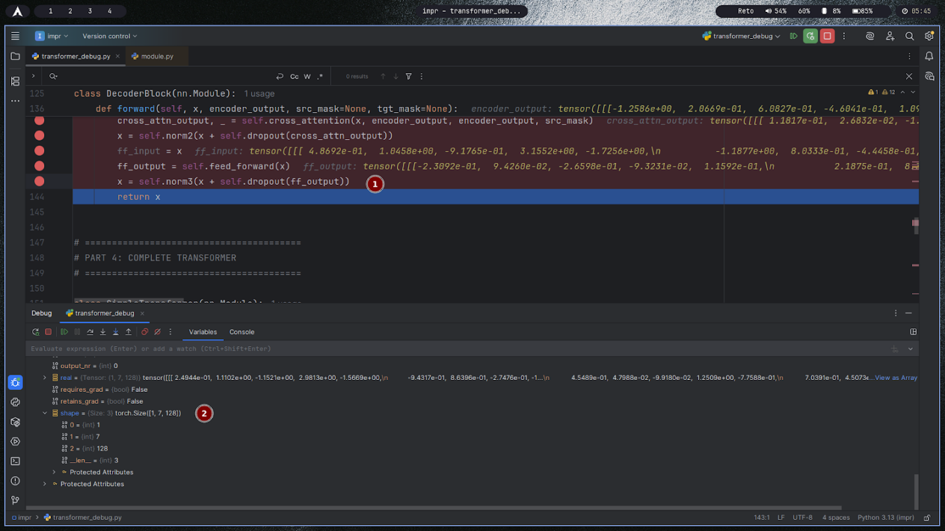

- summary:
This screenshot shows the final step of a Transformer decoder block where the feed-forward output is passed through dropout, added residually to the block input, normalized, and then returned as the block’s output tensor. The returned tensor is the per-token hidden state that proceeds to the next decoder block or to the output projection head.
- Plain Text:
ff_output = feed_forward(x)
x = norm3(x + dropout(ff_output))
return x # decoder block output
- Why the data holds those specific values:
Residual addition combines the prior representation with the feed-forward update, so values reflect both long-range context (from attention) and local nonlinear transformation (from FFN).
Dropout slightly reduces activation magnitudes by randomly zeroing a subset of features during training, improving generalization.
LayerNorm then re-centers and re-scales each token’s vector to a stable range, making the output numerically well-conditioned for the next layer or for the logits head.
- How they relate to the theoretical foundation:
A decoder block follows the sequence: masked self-attention → Add-Norm → cross-attention → Add-Norm → position-wise FFN → Add-Norm.
The final Add-Norm produces the block’s hidden state h(l)h(l) for each token, which is fed into the next decoder block or projected to vocabulary logits; this maintains gradient flow via residual paths and stable activations via normalization across deep stacks.

#41 – Final decoder output (before projection)
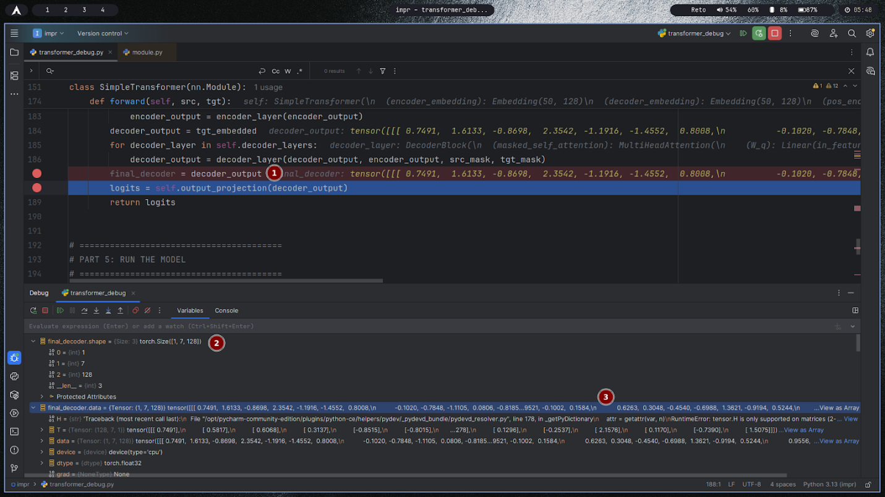

- summary:
This screenshot shows the end of a Transformer’s forward method where the final decoder hidden states are ready to be mapped to vocabulary logits by a linear output projection. The tensor labeled final_decoder = decoder_output is the sequence of per-token embeddings produced after all decoder blocks.
- Plain Text:
encoder_output = encoder_layer(encoder_input)
decoder_output = tgt_embedding + positional_encoding
for block in decoder_layers: decoder_output = block(decoder_output, encoder_output, masks)
final_decoder = decoder_output # hidden states before projection
logits = output_projection(final_decoder)
return logits
- Why the data holds those specific values:
Each vector in final_decoder aggregates information from masked self-attention (past tokens), cross-attention (encoder context), and the FFN, with residuals and normalization stabilizing magnitudes.
The values are in model dimension d_model and not yet tied to vocabulary; they reflect features useful for predicting the next token but must be linearly transformed to compare against all vocabulary embeddings.
The subsequent output_projection multiplies by a weight matrix of shape d_model × vocab_size (often tied with the embedding matrix), converting features into logits whose softmax yields token probabilities.
- How they relate to the theoretical foundation:
Autoregressive decoding models p(yt∣y<t,x)p(yt∣y<t,x) by computing hidden states htht and then logits lt=htWout+blt=htWout+b; probabilities are pt=softmax(lt).
The final decoder states are precisely the htht terms; the output projection implements the linear classification head into the vocabulary space, enabling sampling or loss computation against target tokens.

#42 – Logits (after projection layer)
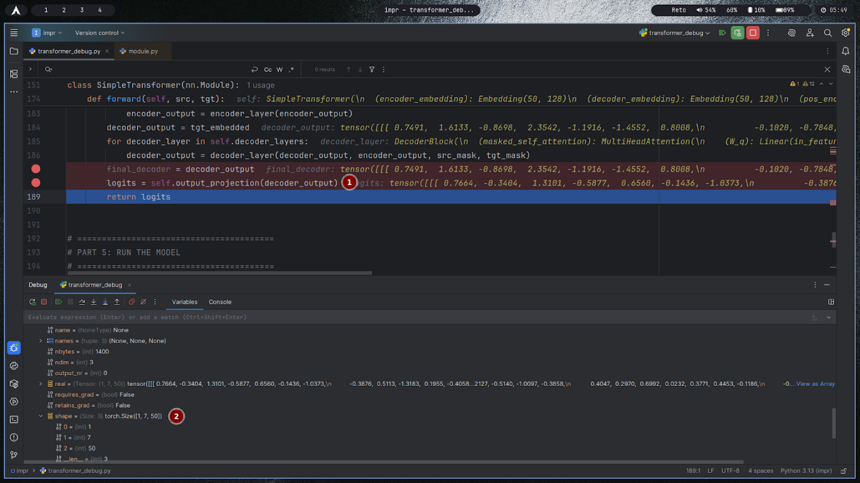

- summary:
This screenshot shows the final stage of the Transformer forward pass where the decoder’s last hidden states are passed through the output projection to produce logits. The logits tensor contains unnormalized scores over the vocabulary for each time step and will be used for softmax and loss or sampling.
- Plain Text:
final_decoder = decoder_output
logits = output_projection(final_decoder) # shape: (batch, seq_len, vocab_size)
return logits
- Why the data holds those specific values:
The output projection is a linear map from model dimension to vocabulary size; each logit is a dot product between a hidden state and a column of the projection matrix plus a bias, so values reflect similarity between the hidden state and each token’s “unembedding” vector.
Larger positive logits correspond to tokens whose embeddings align with the hidden state; lower or negative logits indicate weaker alignment.
If weight tying is used, the projection shares weights with the input embedding, constraining logits to be computed against the same token embedding space and reducing parameters.
- How they relate to the theoretical foundation:
For next-token prediction, probabilities are obtained by applying softmax to logits: pt(w)=softmax(htWout+b)wpt(w)=softmax(htWout+b)w, and training minimizes cross-entropy between this distribution and the target token.
The projection realizes the classifier that maps sequence representations to vocabulary space; its parameters learn to align hidden states with correct token directions, enabling decoding and gradient flow back through the entire network.

#43 – Logits slice (first token’s first 10 values)
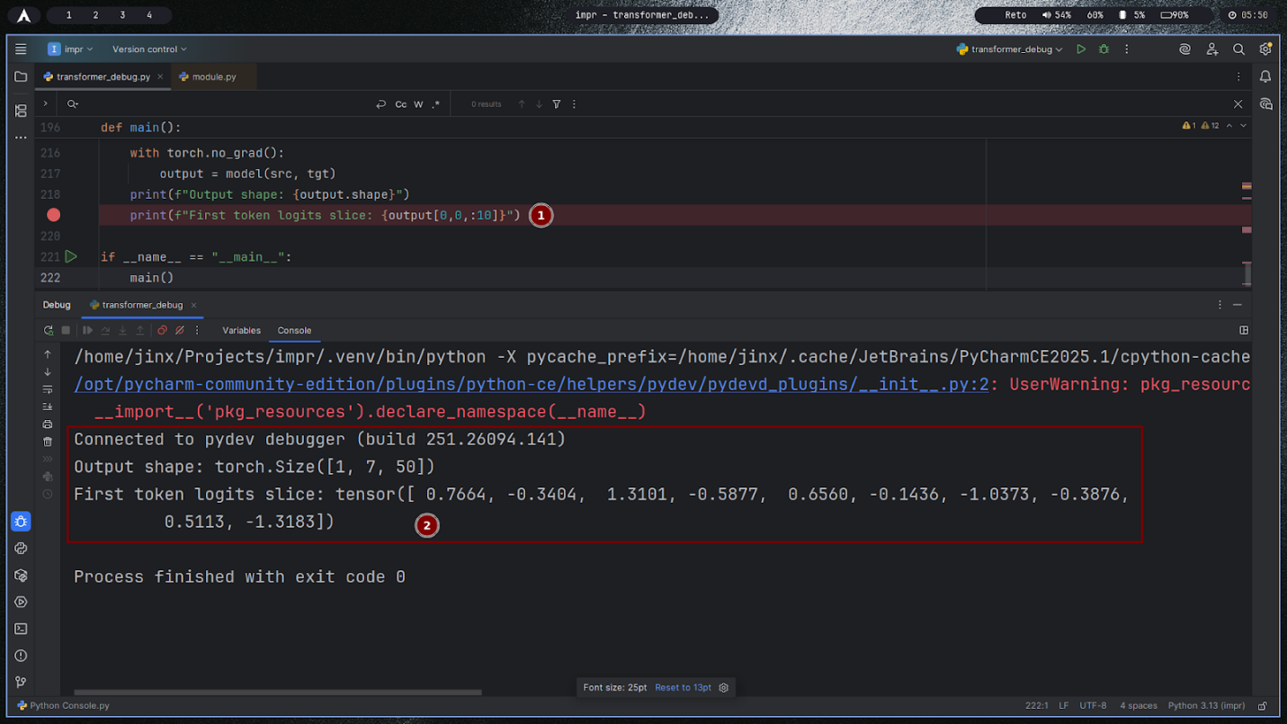

- summary:
The screenshot prints a slice of the logits for the first token: ten unnormalized scores from the output projection. These values will be turned into probabilities by applying softmax across the vocabulary dimension.
- Plain Text:
Output shape: torch.Size() # batch=1, sequence length=7, vocab size=50
First token logits slice: tensor([0.7664, -0.3404, 1.3101, -0.5877, 0.6560, -0.1436, -1.0373, -0.3876, 0.5113, -1.3183])
- Why the data holds those specific values:
Each number is a dot product between the first token’s hidden state and one vocabulary vector plus bias, so larger positives indicate closer alignment and thus higher post-softmax probability.
Negative logits are common and simply mean those tokens are less aligned with the hidden state; only relative differences matter, since softmax is invariant to adding a constant shift across all logits.
The slice shows just 10 of 50 scores; probabilities will be influenced by all 50 logits because softmax normalizes over the full set.
- How they relate to the theoretical foundation:
For vocabulary size VV, logits z∈RVz∈RV are converted to probabilities by pi=exp⁡(zi)/∑jexp⁡(zj)pi=exp(zi)/∑jexp(zj).
The argmax of logits equals the argmax of probabilities, so ranking tokens by these scores yields the same next-token choice as softmax; training uses cross-entropy on the softmax probabilities to update the model.

Guiding Questions:-
q1. What do each of the dimensions represent at embedding, attention, feed-forward, and output stages?
Answer:
Embedding: Each token is mapped to a vector of size dmodel, so the input tensor is [batch,sequence,dmodel]. This represents the meaning of each token in a high-dimensional space.
Attention: The input is projected into Query (Q), Key (K), and Value (V) tensors, each split into multiple heads. Each head has dimension dh=dmodel/H, so Q/K/V per head are [batch,head,sequence,dh]. Attention scores are [batch,head,sequence,sequence].
Feed-forward: Each token's vector is processed independently by a small neural network, typically expanding to dffdff (often 2–4× dmodeldmodel), then projected back to dmodeldmodel. Shape stays [batch,sequence,dmodel].
Output: The final decoder output is projected to vocabulary logits: [batch,sequence,∣V∣], where ∣V∣ is the vocabulary size.

q2. Why do Q, K, V tensors have the same shape, and why are they split into heads?
Answer:
Q, K, and V must have the same shape per head so that dot-product attention (QK^⊤) is valid and each query can compare to every key. Splitting into heads lets the model attend to information in different subspaces, increasing expressiveness and parallelism.

q3. What do the attention score matrices represent, and why must they be square?
Answer:
The attention score matrix (QK^⊤) shows how much each token should attend to every other token in the sequence. In self-attention, both Q and K come from the same sequence, so the score matrix is square: [sequence,sequence].

q4. Why is masking necessary in the decoder, and how does the mask tensor enforce it?
Answer:
Masking prevents the decoder from "cheating" by looking at future tokens during training or generation. The mask tensor sets attention scores for future positions to −∞, so after softmax, those probabilities become zero, enforcing autoregressive prediction.

q5. How do residual connections and layer normalization ensure consistency of shapes across blocks?
Answer:
Residual connections add the input to the output of each sublayer, so both must have the same shape ([batch,sequence,dmodel]). Layer normalization is applied to each token's vector, keeping the shape unchanged. This consistency allows stacking many blocks without shape mismatches.

q6. Why must the embedding dimension remain constant through all layers?
Answer:
Keeping dmodel constant ensures that every block's input and output shapes match, which is required for residual connections and for stacking layers. It also allows the final output to be projected directly to vocabulary logits.

q7. How does the final projection connect decoder output to vocabulary logits?
Answer:
The decoder's final output (shape [batch,sequence,dmodel]) is passed through a linear layer that maps each token's vector to a vector of size ∣V∣, producing logits for each possible token in the vocabulary. This enables the model to predict the next token.

